Problem 7.76

Using the PSPICE Schematics editor, draw the circuit shown. At what frequency are the magnitudes of i_{C}(t) and i_{L}(t) equal?

Suggested Solution
This Schematics circuit was simulated over the frequency range 100 Hz to 300 Hz. Since current into pin markers were placed in the circuit, PROBE will automatically plot the required current magnitudes. 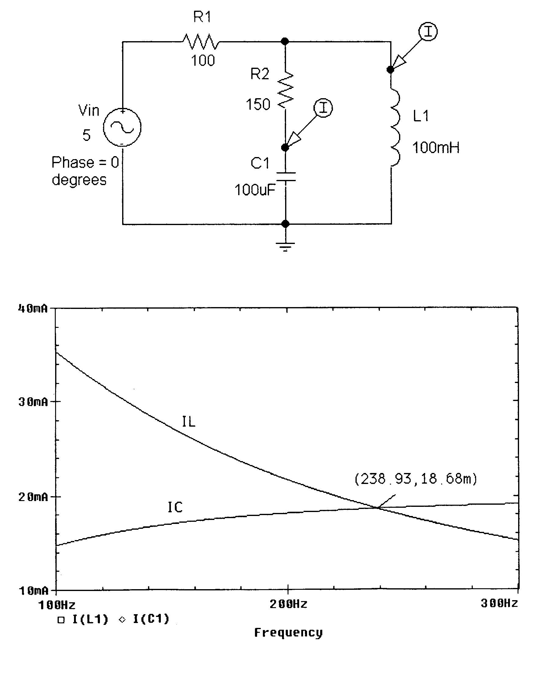

PROBE results show that the voltage and current phases are roughly equal at 238.9 Hz

