Problem 7.77

Using the PSPICE Schematics editor, draw the circuit shown. At what frequency are the phases of i_{l}(t) and v_{x}(t) equal?

Suggested Solution
This Schematics circuit was simulated over the frequency range 1 kHz to 2 kHz. Since vphase and iphase markers were placed in the circuit, PROBE will automatically plot the required voltage and current phase angles.
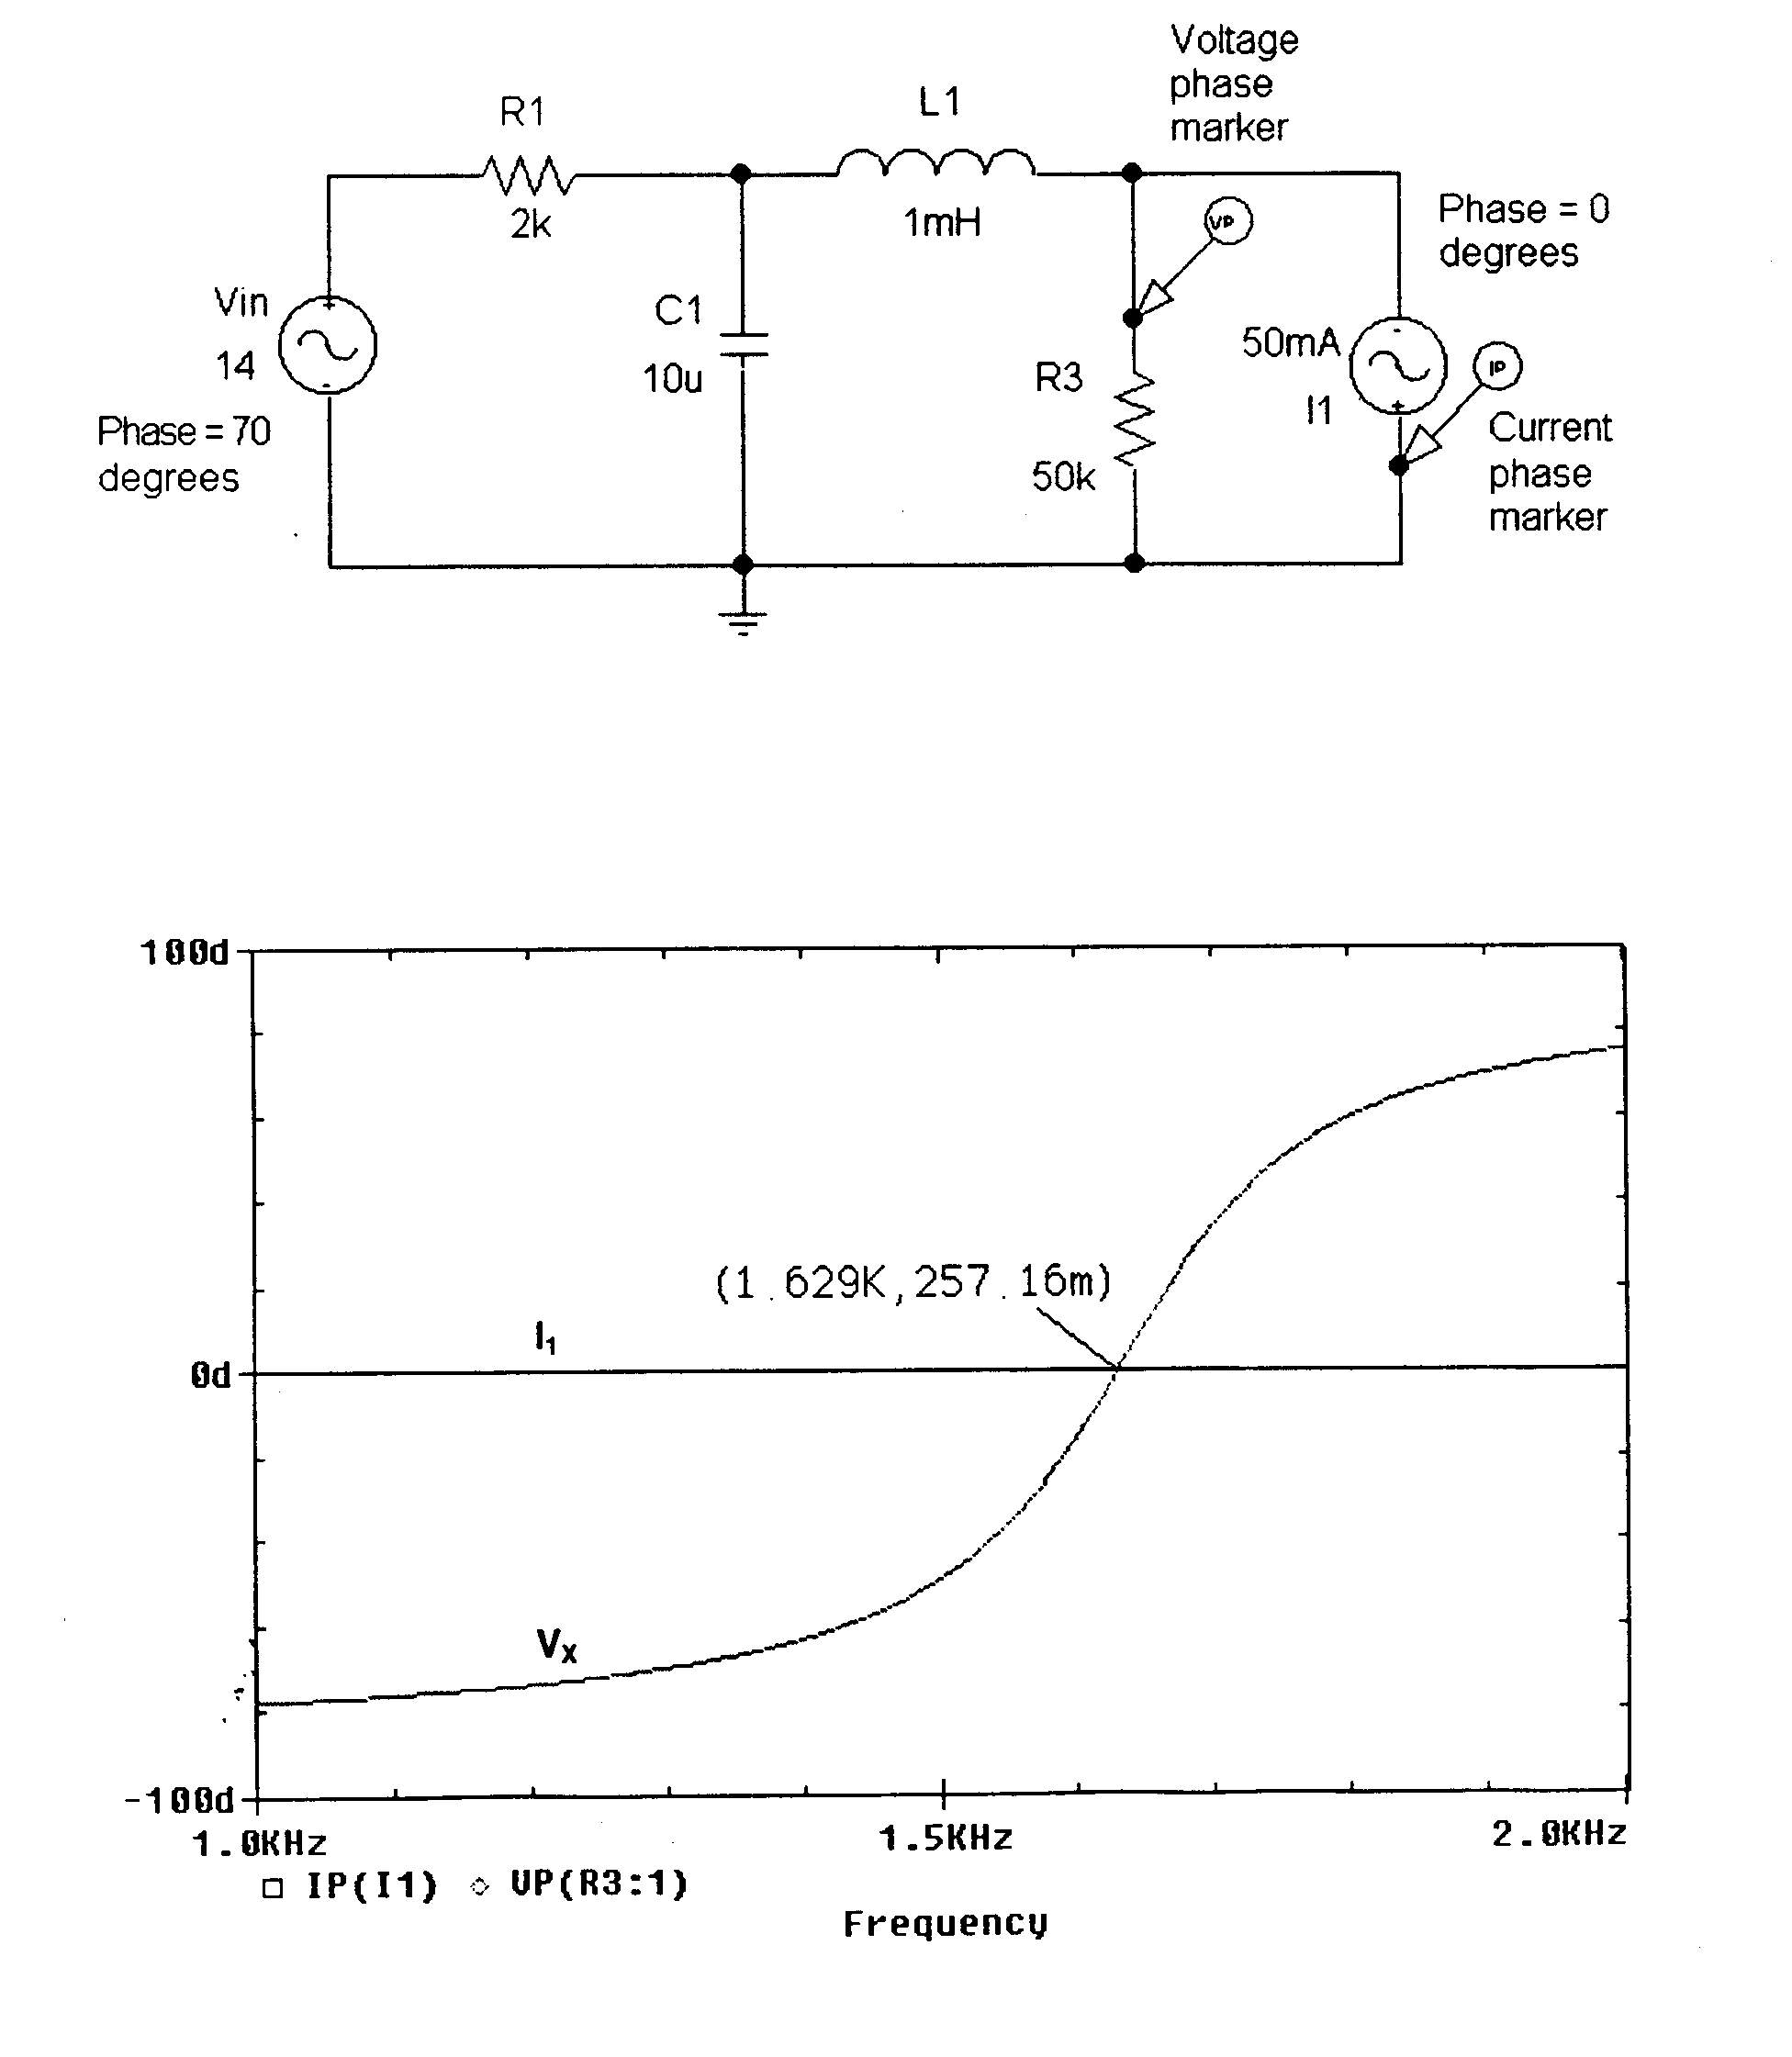
PROBE results show that the voltage and current phases are roughly equal at 1.63 kHz.

