Problem 14.1

Find the exponential Fourier series for the signal shown.

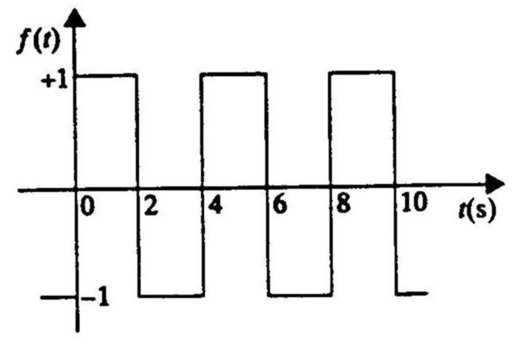

Suggested Solution

