Problem 14.2

Find the exponential Fourier series for the periodic pulse train shown.

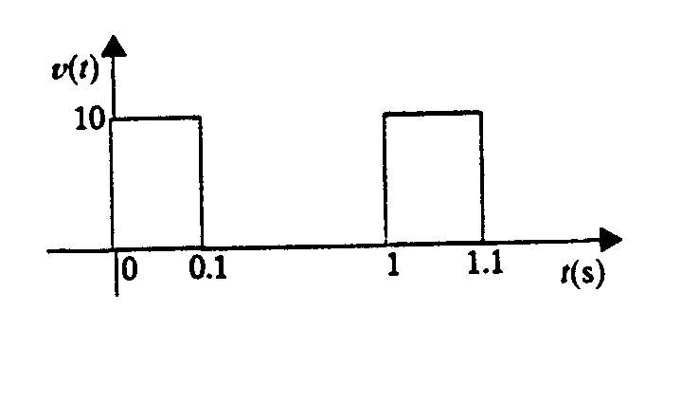

Suggested Solution

