Problem 14.3

Find the exponential Fourier series for the periodic signal shown.

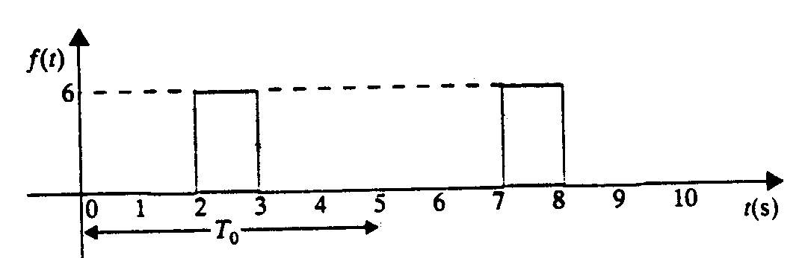

Suggested Solution

