Problem 14.4

Compute the exponential Fourier series for the waveform that is the sum of the two waveforms shown by computing the exponential Fourier series of the two waveforms and adding them.

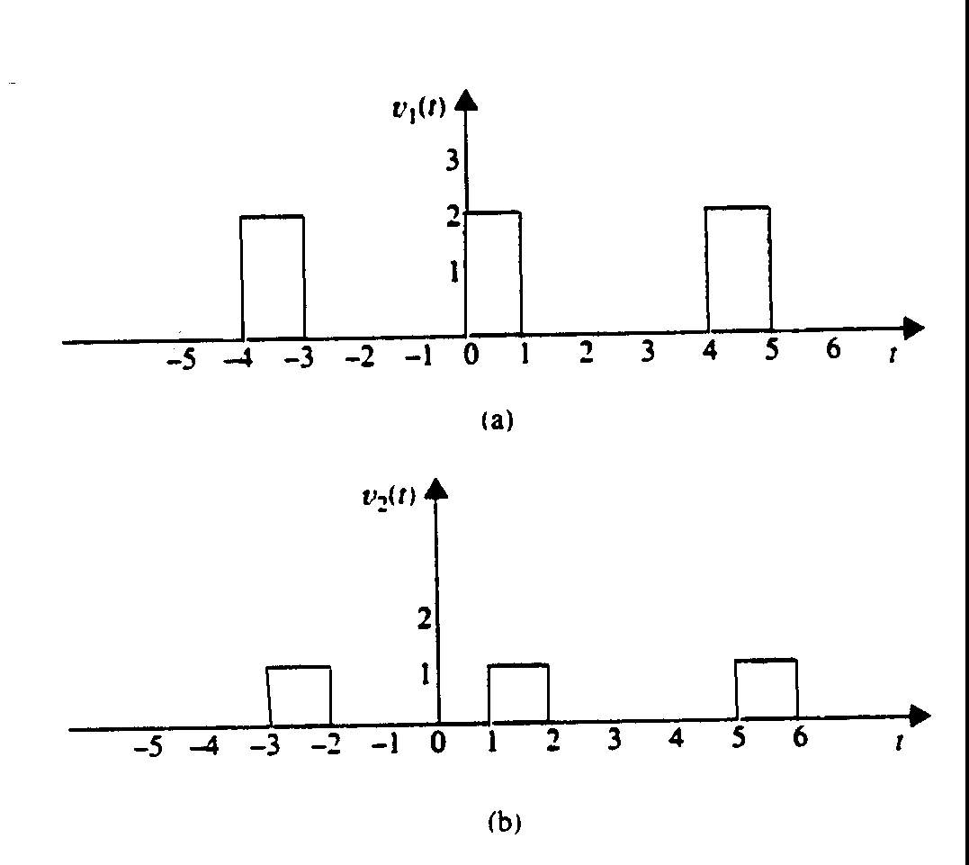

Suggested Solution

