Problem 14.5

Find the exponential Fourier series for the signal shown.

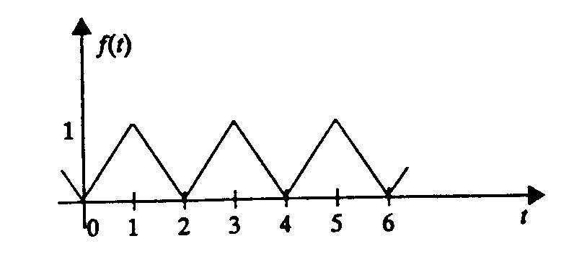

Suggested Solution

