Problem 14.6

Given the waveform shown, determine the type of symmetry that exists if the origin is selected at: (a) l₁ and (b) l₂.

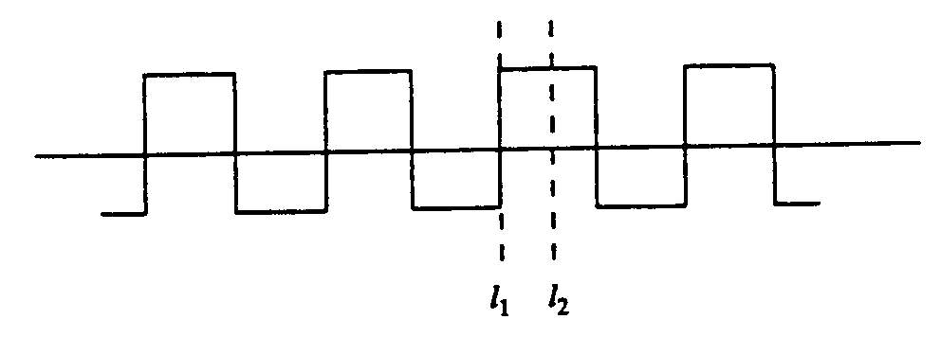

Suggested Solution

If origin is at l₁, then v (t) = -v(- t) odd symmetry

If origin is at l₂, then v (t) = v (-t) even symmetry

