Problem 14.7

What type of symmetry is exhibited by the two waveforms shown?

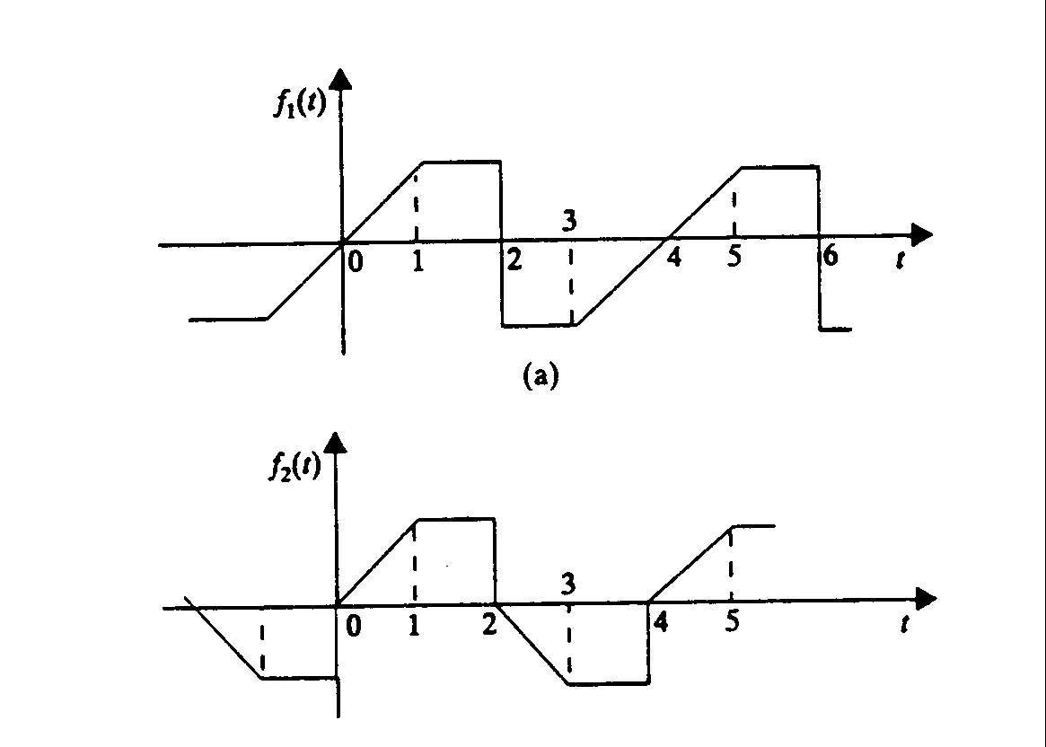
(b)

Suggested Solution

In part a) f₁ (t) = -f₁ (t) odd symmetry

In part b) f₂ (t) = -f₂ (t- T₀/2) half wave symmetry

