Problem 14.8

Derive the trigonometric Fourier series for the waveform shown.

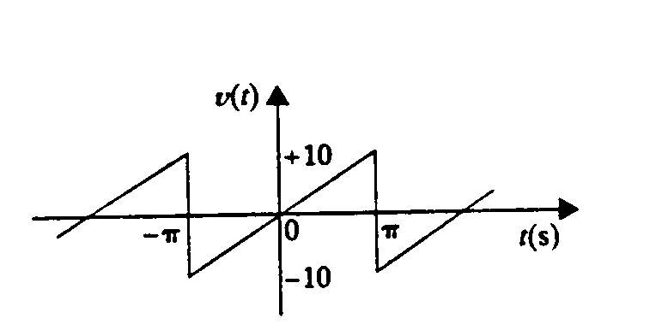

Suggested Solution

