Problem 14.9

Find the trigonometric Fourier series coefficients for the waveform shown.

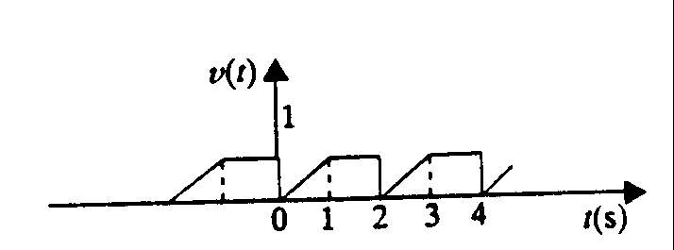

Suggested Solution

