Problem 14.10

Find the trigonometric Fourier series coefficients for the waveform shown.
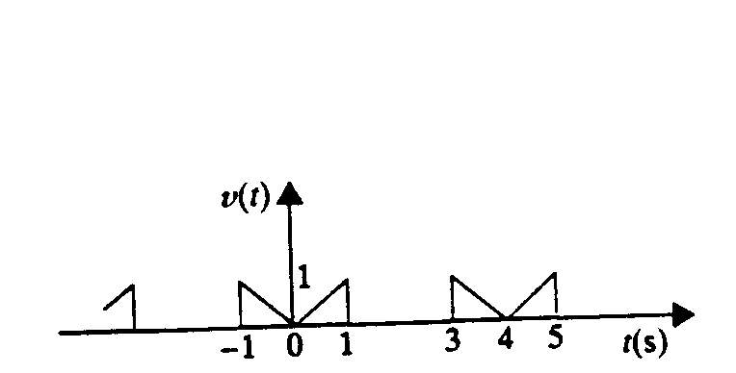

Suggested Solution

