Problem 14.11

Find the trigonometric Fourier series coefficients for the waveform shown.

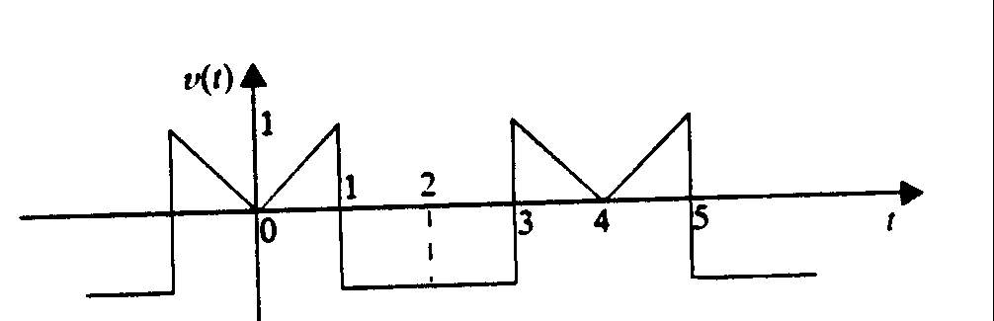

Suggested Solution

