Problem 14.13

Find the trigonometric Fourier series for the waveform shown.

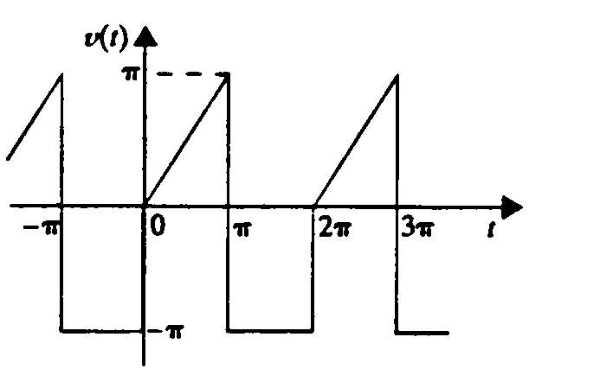

Suggested Solution

