Problem 14.15

Find the trigonometric Fourier series coefficients for the waveform shown.

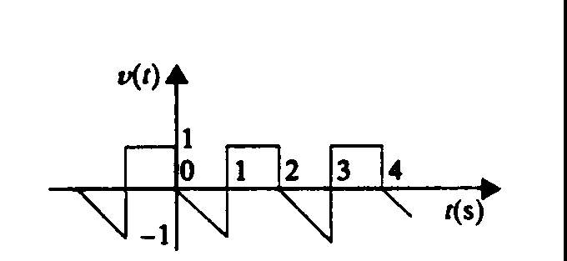

Suggested Solution

