Problem 14.17

Derive the trigonometric Fourier series for the function shown.

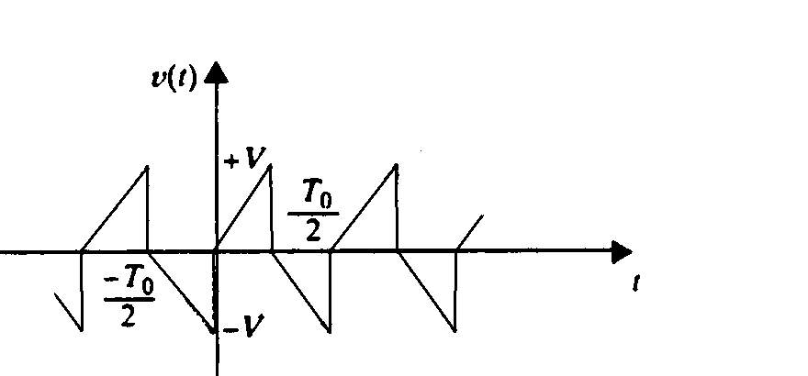

Suggested Solution

