Problem 14.18

Derive the trigonometric Fourier series for the function v(t) = A|sin t| as shown.

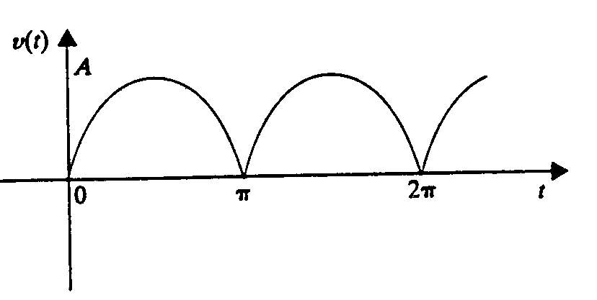

Suggested Solution

