Problem 14.19

Derive the trigonometric Fourier series for the waveform shown.

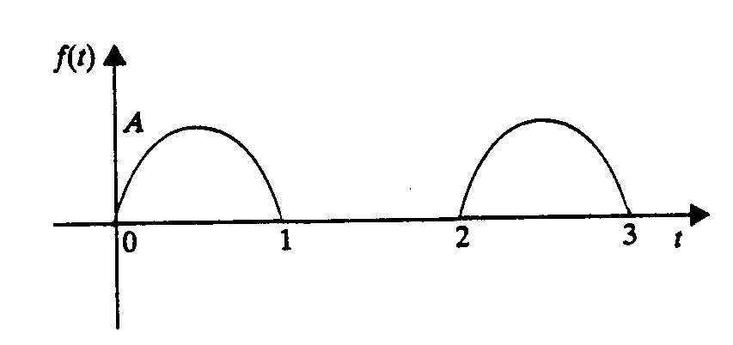

Suggested Solution

