Problem 14.20

Use PSpice to determine the Fourier series of the waveform shown in the form.
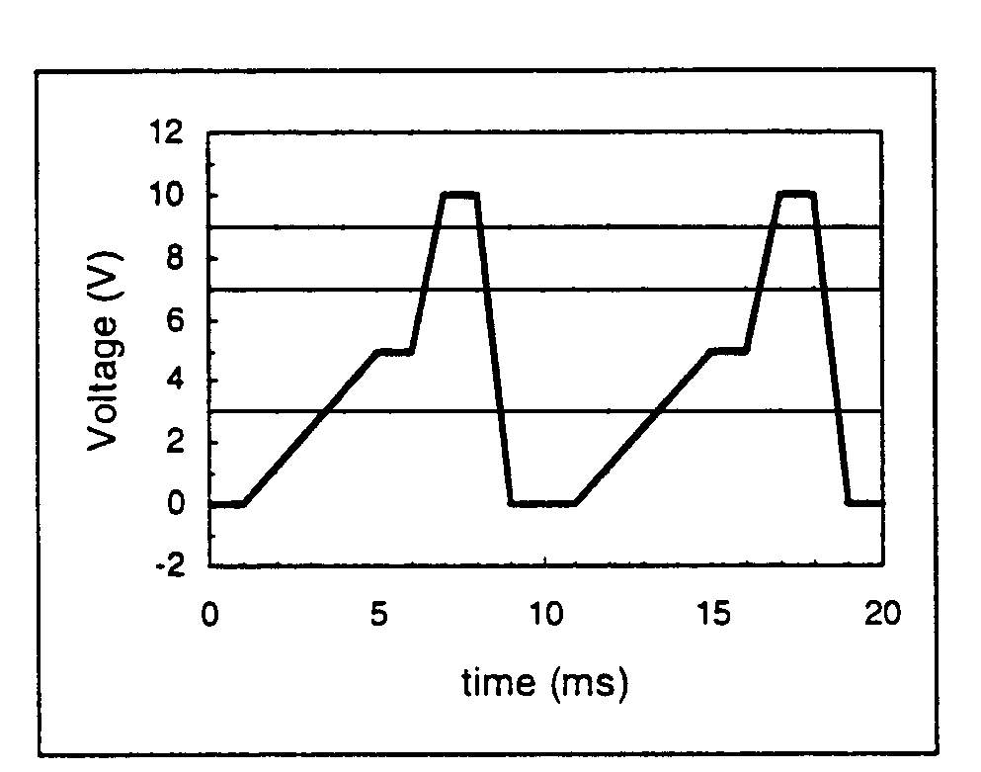

Suggested Solution

Transient specifics were Final Time=10ms, Step Ceiling=10us,
Center Frequency=100 Hz and Number of Harmonics=10

FOURIER COMPONENTS OF TRANSIENT RESPONSE V(Vs)
DC COMPONENT= 3.750000E+00

HARMONIC FREQUENCY FOURIER NORMALIZED PHASE NORMALIZED
NO (HZ) COMPONENT COMPONENT (DEG) PHASE(DEG)
1 1.000E+02 3.954E+00 1.000E+00 -1.424E+02 0.000E+00
2 2.000E+02 2.016E+00 5.099E-01 -8.774E+01 1.971E+02
3 3.000E+02 1.247E+00 3.154E-01 -8.735E+00 4.185E+02
4 4.000E+02 6.417E-01 1.623E-01 6.991E+01 6.395E+02
5 5.000E+02 2.027E-01 5.126E-02 9.000E+01 8.020E+02
6 6.000E+02 2.852E-01 7.213E-02 1.101E+02 9.645E+02
7 7.000E+02 2.291E-01 5.793E-02 -1.713E+02 8.256E+02
8 8.000E+02 1.260E-01 3.188E-02 -9.226E+01 1.047E+03
9 9.000E+02 4.883E-02 1.235E-02 -3.759E+01 1.244E+03
10 1.000E+03 1.993E-08 5.040E-09 -1.206E+02 1.303E+03

TOTAL HARMONIC DISTORTION = 6.310255E+01 PERCENT

