Problem 14.21

Use PSpice to determine the Fourier series of the waveform shown in the form
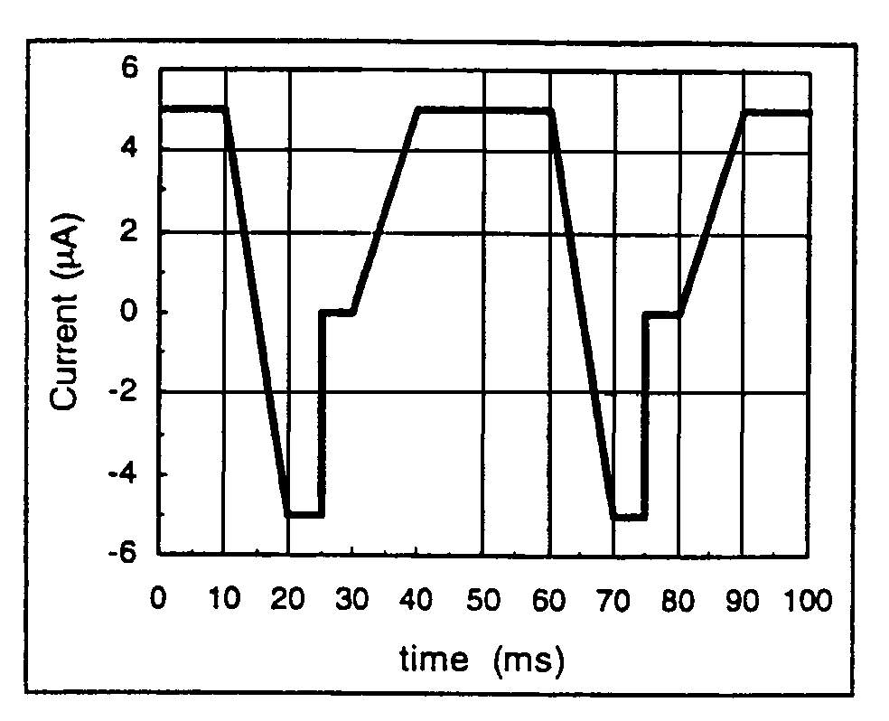

Suggested Solution

Transient specifics were Final Time=10ms, Step Ceiling=10us,
Center Frequency=100 Hz and Number of Harmonics=10

FOURIER COMPONENTS OF TRANSIENT RESPONSE V(Vs)
DC COMPONENT= 1.997500E+00

HARMONIC FREQUENCY FOURIER NORMALIZED PHASE NORMALIZED
NO (HZ) COMPONENT COMPONENT (DEG) PHASE(DEG)
1 2.000E+01 4.401E+00 1.000E+00 1.049E+02 0.000E+00
2 4.000E+01 1.669E+00 3.792E-01 -3.975E+01 -2.495E+02
3 6.000E+01 8.810E-01 2.002E-01 -1.480E+02 -4.627E+02
4 8.000E+01 4.518E-01 1.027E-01 3.521E+01 -3.844E+02
5 1.000E+02 3.183E-01 7.233E-02 1.791E+02 -3.454E+02
6 1.200E+02 3.001E-01 6.819E-02 2.212E+01 -6.073E+02
7 1.400E+02 2.046E-01 4.648E-02 -1.565E+02 -8.907E+02
8 1.600E+02 1.829E-01 4.157E-02 -2.297E+01 -8.621E+02
9 1.800E+02 1.913E-01 4.347E-02 1.625E+02 -7.816E+02
10 2.000E+02 1.592E-01 3.617E-02 -1.800E+00 -1.051E+03

TOTAL HARMONIC DISTORTION= 4.597325E+O1 PERCENT

