Problem 14.22

The discrete line spectrum for a periodic function f(t) is shown. Determine the expression for f(t).

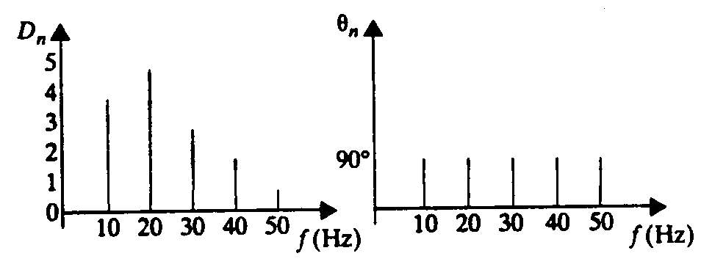

Suggested Solution

