Problem 14.23

The amplitude and phase spectra for a periodic function v(t) that has only a small number of terms is shown. Determine the expression for v(t) if T₀ = 0.1 s.

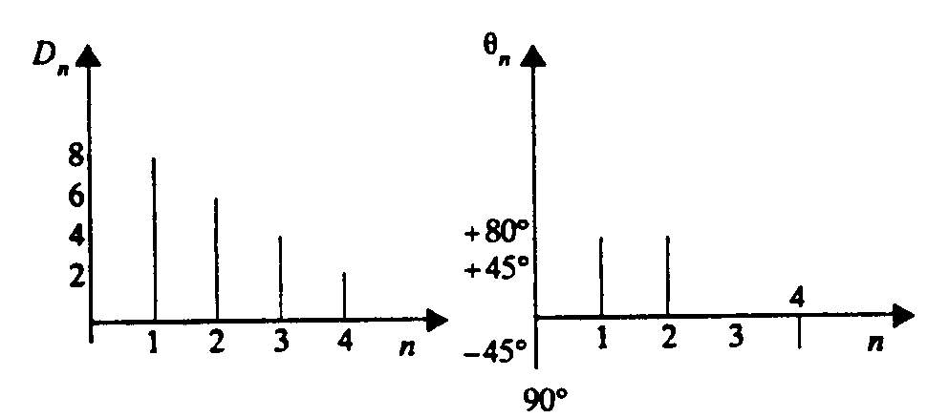

Suggested Solution

