Problem 14.28

The current I_{s} (t) shown is applied to the circuit shown. Determine the expression for the steady-state current i_{o} (t) using the first four harmonics.

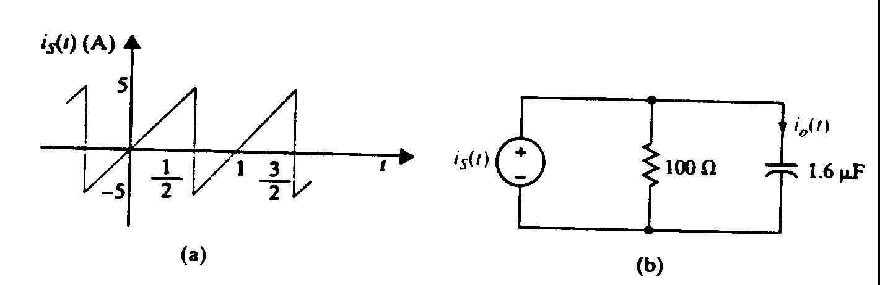

Suggested Solution

