Problem 14.31

Determine the Fourier transform of the waveform shown.

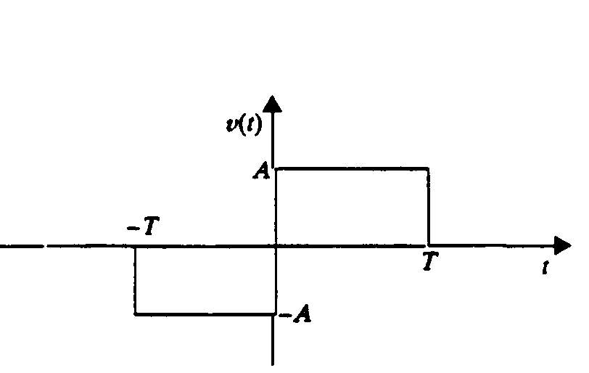

Suggested Solution

