26.17:
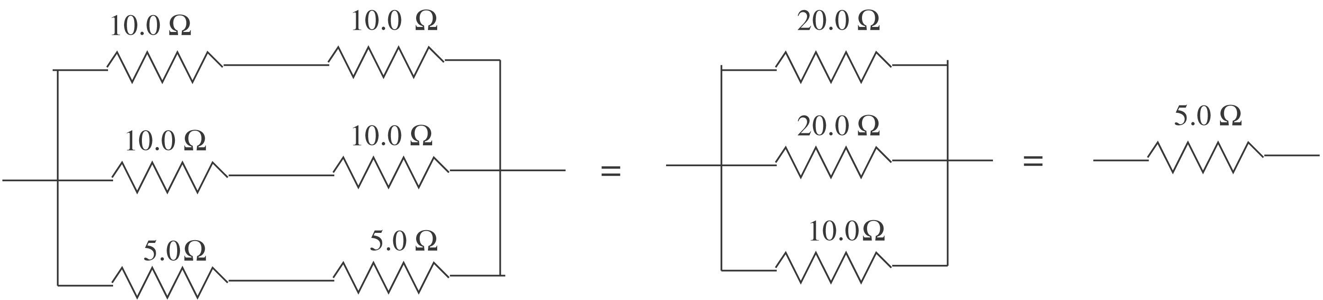

$\text{30}\text{.}0 V−I (\text{20}\text{.}0 Ω+5\text{.}0 Ω+5\text{.}0 Ω)=0;$ I = 1.00 A
For the $\text{20}\text{.}0−Ω$ resistor thermal energy is generated at the rate $P=I^{2}R=\text{20}\text{.}0 W\text{.}$
$Q=\text{Pt} \text{and} Q=\text{mc}ΔT \text{gives}$
$t=\frac{\text{mc}ΔT}{P}=\frac{(0\text{.}\text{100} \text{kg}) (\text{4190} J/\text{kg} ⋅ K) (\text{40}\text{.}0 C°)}{\text{20}\text{.}0 W}=1\text{.}\text{01}×{\text{10}}^{3}s$

