26.28: Given that the full-scale deflection current is 500 $μA$ and the coil resistance is $\text{25}\text{.}0 Ω:$
a) For a 20-mA ammeter, the two resistances are in parallel:
$\begin{aligned}V_{c}=V_{s}⇒I_{c}R_{c}=I_{s}R_{s}⇒\left(\text{500}×{\text{10}}^{−6} A\right) \left(\text{25}\text{.}0 Ω\right)=\left(\text{20}×{\text{10}}^{−3} A−\text{500}×{\text{10}}^{−6} A\right)R_{s} \\ ⇒R_{s}=0\text{.}\text{641} Ω\end{aligned}$

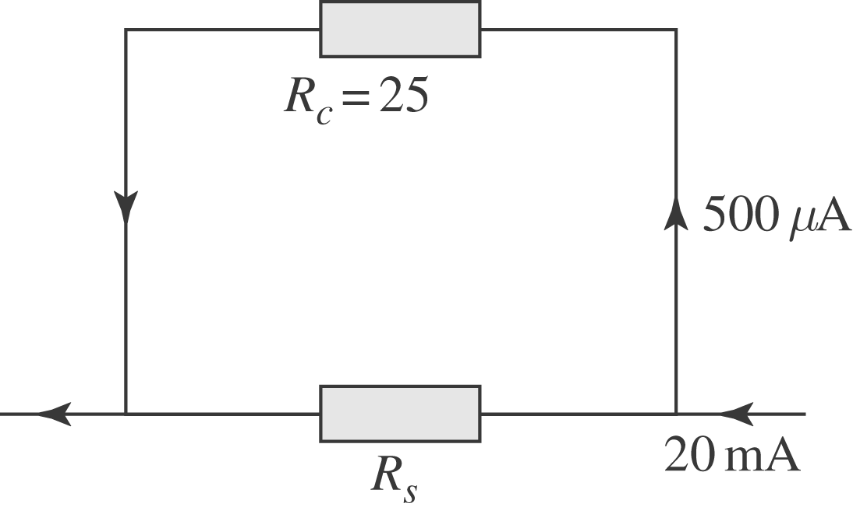

b) For a 500-m voltmeter, the resistances are in series:
$\begin{aligned}V_{\text{ab}}=I\left(R_{c}+R_{s}\right)⇒R_{s}⇒\frac{V_{\text{ab}}}{I}−R_{c} \\ ⇒R_{s}=\frac{\text{500}×{\text{10}}^{−3} V}{\text{500}×{\text{10}}^{−6} A}−\text{25}\text{.}0 Ω=\text{975} Ω\text{.}\end{aligned}$

