26.39: a) The time constant $\text{RC} = (0\text{.}\text{895} × {\text{10}}^{6} Ω) (\text{12}\text{.}4 × {\text{10}}^{−6} F) = \text{11}\text{.}1 s\text{.} \text{So} \text{at:}$
$t = 0 s: q = \text{Cε}(1 − e^{{−t}/{\text{RC}}}) = 0\text{.}$
$\begin{aligned}t = 5 s: q = \text{Cε}(1 − e^{{−t}/{\text{RC}}}) = (\text{12}\text{.}4 × {\text{10}}^{−6} F) (\text{60}\text{.}0 V) (1 − e^{−(5\text{.}0 s)/(\text{11}\text{.}1 s)}) \\ = 2\text{.}\text{70} × {\text{10}}^{−4} C\text{.}\end{aligned}$
$\begin{aligned}t = \text{10} \text{s:} q = \text{Cε}(1 − e^{{−t}/{\text{RC}}}) = (\text{12}\text{.}4 × {\text{10}}^{−6} F) (\text{60}\text{.}0 V) (1−e^{−(\text{10}\text{.}0 s)/(\text{11}\text{.}1 s)}) \\ = 4\text{.}\text{42} × {\text{10}}^{−4} C\text{.}\end{aligned}$
$\begin{aligned}t = \text{20} s: q = \text{Cε}(1−e^{{−t}/{\text{RC}}}) = (\text{12}\text{.}4 × {\text{10}}^{−6} F) (\text{60}\text{.}0 V) (1− e^{−(\text{20}\text{.}0 s)/(\text{11}\text{.}1 s)}) \\ =6\text{.}\text{21} × {\text{10}}^{−4} C\text{.}\end{aligned}$
$\begin{aligned}t = \text{100} s: q = \text{Cε}(1 − e^{{−t}/{\text{RC}}}) = (\text{12}\text{.}4 × {\text{10}}^{−6} F) (\text{60}\text{.}0 V) (1 − e^{−(\text{100} s)/(\text{11}\text{.}1 s)}) \\ = 7\text{.}\text{44} × {\text{10}}^{−4} C\text{.}\end{aligned}$
b) The current at time t is given by: $i = \frac{ε}{R}e^{{−t}/{\text{RC}}}\text{.} \text{So} \text{at:}$
$t = 0 s: i = \frac{\text{60}\text{.}0 V}{8\text{.}\text{95} × {\text{10}}^{5} Ω}e^{{−0}/{\text{11}}\text{.}1} = 6\text{.}\text{70} × {\text{10}}^{−5} A\text{.}$
$t = 5 s: i = \frac{\text{60}\text{.}0 V}{8\text{.}\text{95} × {\text{10}}^{5} Ω}e^{{−5}/{\text{11}}\text{.}1} = 4\text{.}\text{27} × {\text{10}}^{−5} A\text{.}$
$t = \text{10} s: i = \frac{\text{60}\text{.}0 V}{8\text{.}\text{95} × {\text{10}}^{5} Ω}e^{{−\text{10}}/{\text{11}}\text{.}1} = 2\text{.}\text{27} × {\text{10}}^{−5} A\text{.}$
$t = \text{20} \text{s:} i = \frac{\text{60}\text{.}0 V}{8\text{.}\text{95} × {\text{10}}^{5} Ω}e^{{−\text{20}}/{\text{11}}\text{.}1} = 1\text{.}\text{11} ×{\text{10}}^{−5} A\text{.}$
$t = \text{100} s: i = \frac{\text{60}\text{.}0 V}{8\text{.}\text{95} × {\text{10}}^{5} Ω}e^{{−\text{100}}/{\text{11}}\text{.}1} = 8\text{.}\text{20} × {\text{10}}^{−9} A\text{.}$
c) Charge against time:

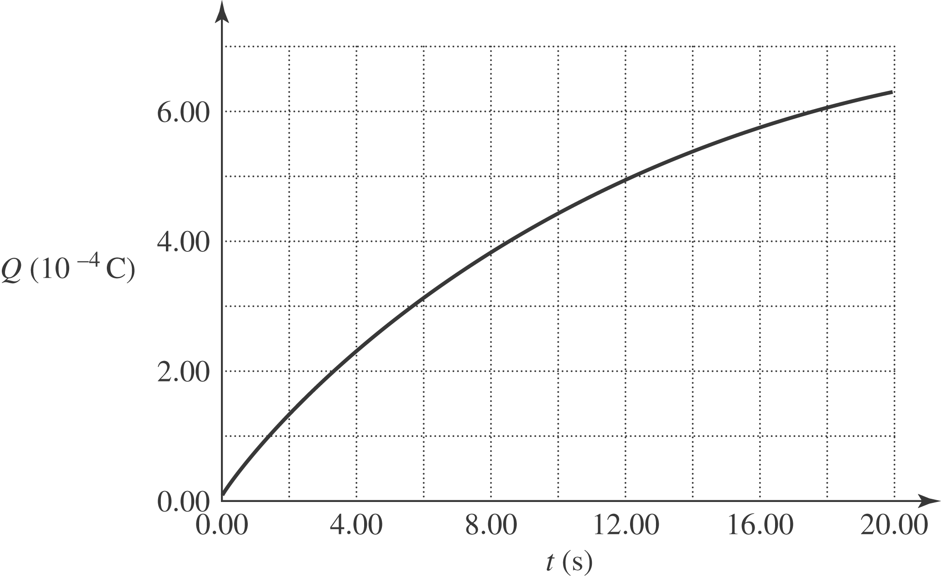

Current against time:

