26.48: a)
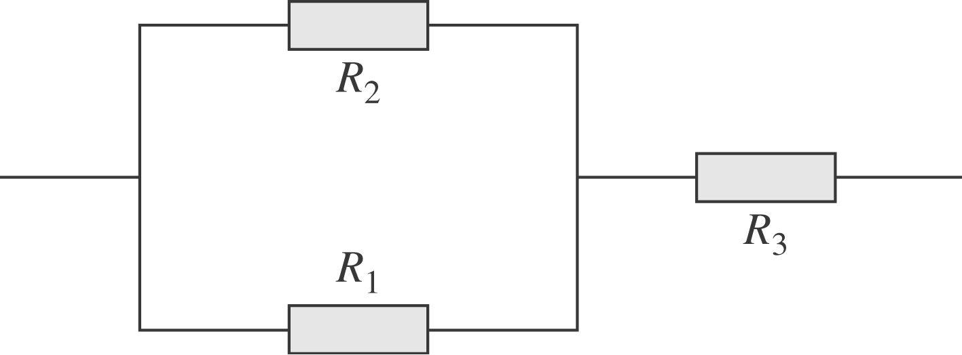
$$\begin{aligned}R_{\text{eq}} = R_{3} + {\left(\frac{1}{R_{1}} + \frac{1}{R_{2}}\right)}^{−1} = R_{3} + \left(\frac{R_{1}R_{2}}{R_{{}^{1}} + R_{2}}\right) \\ \text{If} R_{\text{eq}} = R_{1} ⇒ R_{3}= R_{1} − \left(\frac{R_{1}R_{2}}{R_{1} + R_{2}}\right) =\frac{R_{1}^{2}}{R_{1} + R_{2}}\text{.}\end{aligned}$$
b) $R_{\text{eq}} = {\left(\frac{1}{R_{1} + R_{2}} + \frac{1}{R_{3}}\right)}^{−1}= \frac{R_{3}(R_{1} + R_{2})}{R_{1} + R_{2} + R_{3}}$
$\text{If} R_{\text{eq}} = R_{1} ⇒ R_{1}(R_{1} + R_{2} +R_{3}) = R_{3}(R_{1} +R_{2}) ⇒ R_{3}=R_{1} (R_{1} + R_{2})/{R_{2}}\text{.}$
