26.49: a) We wanted a total resistance $\text{of}\text{400} Ω \text{and} \text{power} \text{of}$ $2\text{.}4 W$ from a combination of individual resistors of $\text{400} Ω \text{and} 1\text{.}2 W\text{power-rating}\text{.}$
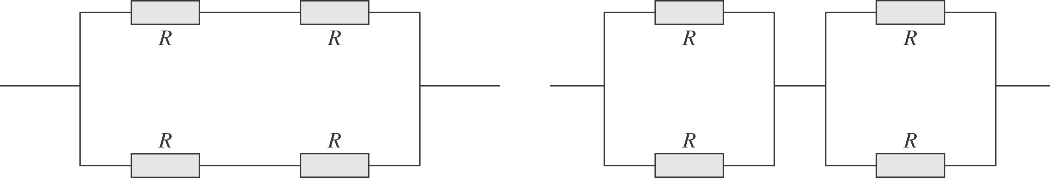
b) The current is given by:$I = \sqrt{P/R} = \sqrt{2\text{.}4 W/{\text{400}} Ω}=0\text{.}\text{077} A\text{.} \text{In}$ each leg half the current flows, so the power in each resistor in each resistor in each combination is the same: $P = (I/2)^{2}R = (0\text{.}\text{039} A)^{2}(\text{400} Ω) = 0\text{.}6 W\text{.}$

