26.50: a) First realize that the Cu and Ni cables are in parallel.
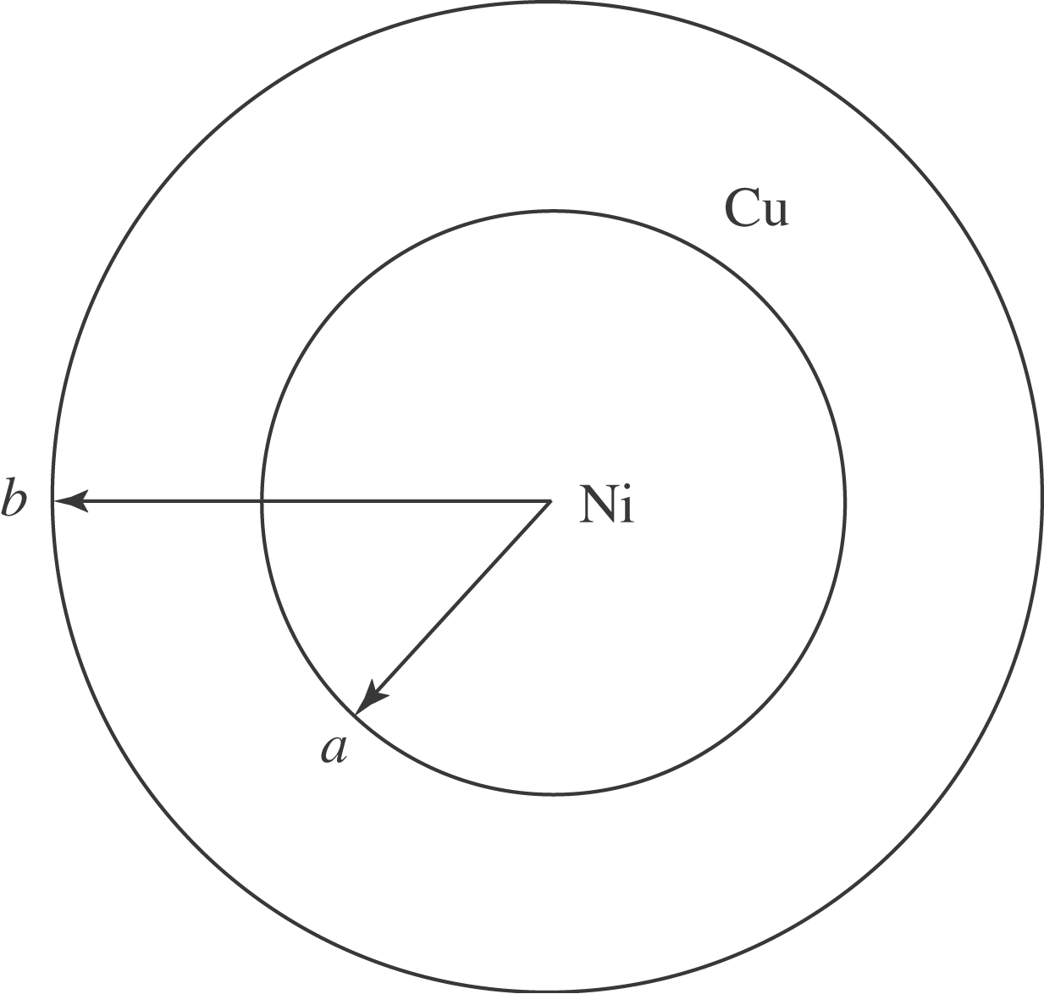
$$\frac{1}{R_{\text{Cable}}}=\frac{1}{R_{\text{Ni}}}+\frac{1}{R_{\text{Cu}}}$$
$$\begin{aligned}R_{\text{Ni}} = ρ_{\text{Ni}}L/A = ρ_{\text{Ni}}\frac{L}{{\text{πa}}^{2}} \\ R_{\text{Cu}} = ρ_{\text{Cu}} L/A = ρ_{\text{Cu}}\frac{L}{π(b^{2} − a^{2})}\end{aligned}$$

So: $\frac{1}{R_{\text{cable}}} = \frac{{\text{πa}}^{2}}{ρ_{\text{Ni}}L} + \frac{π(b^{2} − a^{2})}{ρ_{\text{Cu}}L}$
$\begin{aligned}= \frac{π}{L} \left(\frac{a^{2}}{ρ_{\text{Ni}}} + \frac{b^{2} − a^{2}}{ρ_{\text{Cu}}}\right) \\ \frac{π}{\text{20}m} \left[\frac{(0\text{.}\text{050} m)^{2}}{7\text{.}8 × {\text{10}}^{−8} Ωm} + \frac{(0\text{.}\text{100} m)^{2} − (0\text{.}\text{050} m)2}{1\text{.}\text{72} × {\text{10}}^{−8} Ωm}\right]\end{aligned}$
$R_{\text{Cable}} = \text{13}\text{.}6 × {\text{10}}^{−6} Ω = \text{13}\text{.}6 μΩ$
b) $R = ρ_{\text{eff}} \frac{L}{A} = ρ_{\text{eff}} \frac{L}{{\text{πb}}^{2}}$
$\begin{aligned}ρ_{\text{eff}} = \frac{{\text{πb}}^{2} R}{L} = \frac{π(0\text{.}\text{10} m)^{2} (\text{13}\text{.}6 × {\text{10}}^{−6} Ω)}{\text{20} m} \\ 2\text{.}\text{14} × {\text{10}}^{−8} Ωm\end{aligned}$

