26.51: Let $R = 1\text{.}\text{00} Ω,$the resistance of one wire. Each half of the wire has $R_{h} = R/2\text{.}$
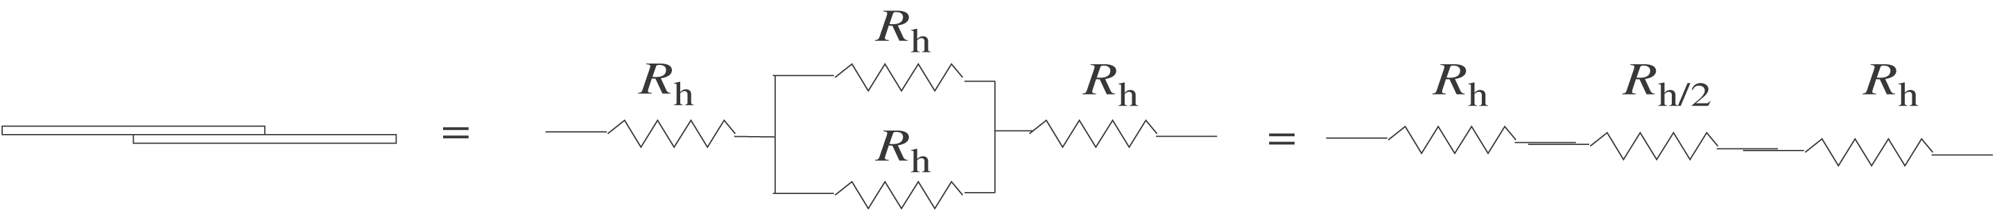
The equivalent resistance is $R_{h} + R_{h}/ 2 + R_{h} = 5R_{h}/2 = \frac{5}{2}(0\text{.}\text{500} Ω) 1\text{.}\text{25} Ω$

