26.54: a) $R_{\text{eq}}(8, \text{16}, \text{16}) = {\left(\frac{1}{8 Ω} + \frac{1}{\text{16} Ω} + \frac{1}{\text{16} Ω}\right)}^{−1} = 4\text{.}0 Ω;$
$R_{\text{eq}}(9, \text{18}) = {\left(\frac{1}{9 Ω} + \frac{1}{\text{18} Ω}\right)}^{−1} = 6\text{.}0 Ω\text{.}$
So the circuit is equivalent to the one shown below. Thus:
$$R_{\text{eq}} = {\left(\frac{1}{6 Ω + 6 Ω} + \frac{1}{\text{20} Ω + 4 Ω}\right)}^{−1} =8\text{.}0 Ω$$
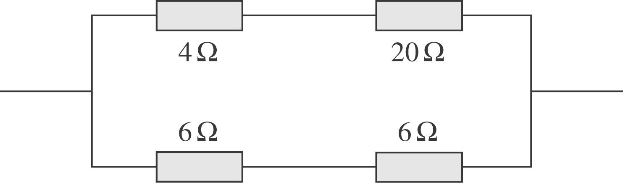
b) If the current through the $8−Ω$ resistor is 2.4 A, then the top branch current is $I(8, \text{16}, \text{16}) = 2\text{.}4 A + \frac{1}{2}2\text{.}4 A + \frac{1}{2}2\text{.}4 A = 4\text{.}8 A\text{.}$But the bottom branch current is twice that of the top, since its resistance is half. Therefore the potential of point a relative to point $x \text{is} V_{\text{ax}} = − {\text{IR}}_{\text{eq}}(9, \text{18}) = − (9\text{.}6 A) (6\text{.}\text{00} Ω) = − \text{58} V\text{.}$

