26.55: Circuit (a) $\begin{aligned}\text{The 75}\text{.}\text{0 }Ω \text{and} \text{40}\text{.}0 Ω \text{resistors} \text{are} \text{in} \text{parallel} \text{and} \text{have} \text{equivalent} \text{resistance} \text{26}\text{.}\text{09} Ω \\ \text{The} \text{25}\text{.}0 Ω \text{and} \text{50}\text{.}0 Ω \text{resistors} \text{are} \text{in} \text{parallel} \text{and} \text{have} \text{equivalent} \text{resistance} \text{16}\text{.}\text{67} Ω\text{.} \\ \text{The} \text{network} \text{is} \text{equivalent} \text{to}\end{aligned}$
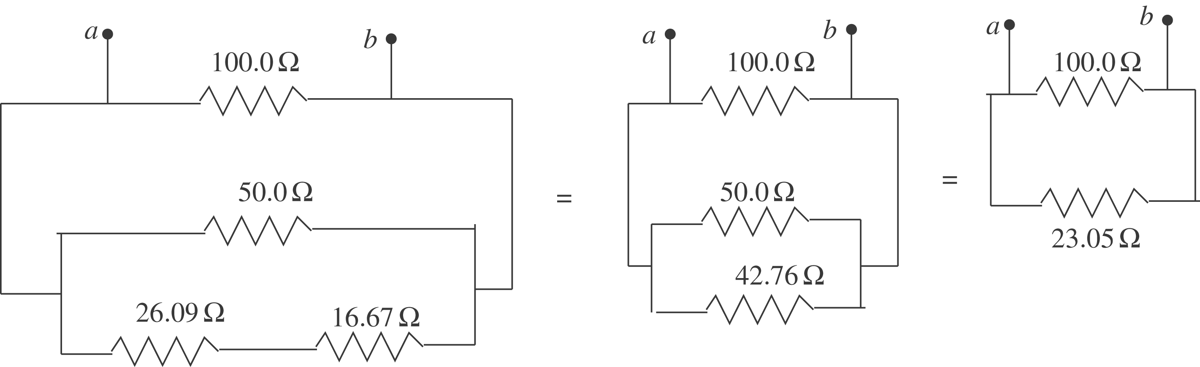
$$\frac{1}{R_{\text{eq}}} = \frac{1}{\text{100}\text{.}0 Ω} + \frac{1}{\text{23}\text{.}\text{05} Ω} \text{so} R_{\text{eq}} = \text{18}\text{.}7 Ω$$
Circuit (b)
The $\text{30}\text{.}0 Ω \text{and} \text{45}\text{.}0 Ω \text{resistors} \text{are} \text{in} \text{parallel} \text{and} \text{have} \text{equivalent} \text{resistance} \text{18}\text{.}0 Ω$.
The network is equivalent to
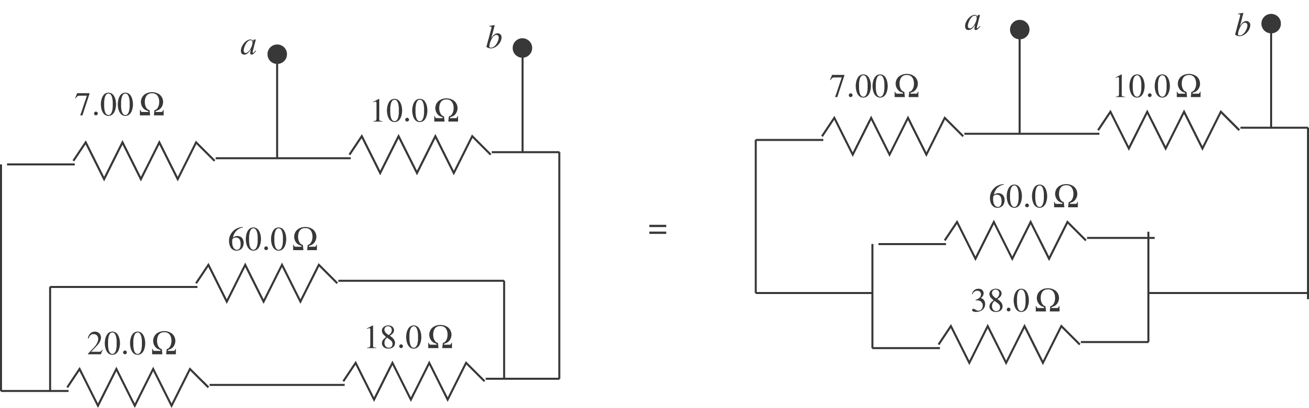
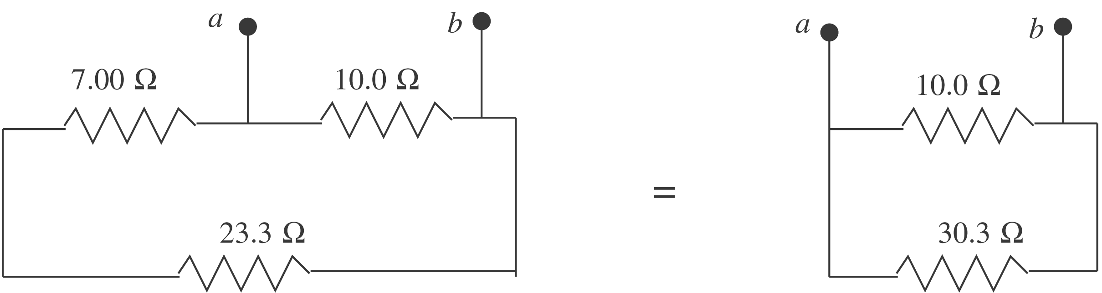
$$\frac{1}{R_{\text{eq}}} = \frac{1}{\text{10}\text{.}0 Ω} + \frac{1}{\text{30}\text{.}3 Ω} \text{so} R_{\text{eq}} = 7\text{.}5 Ω$$

