26.60: a) Using the currents as defined on the circuit diagram below we obtain three equations to solve for the currents:
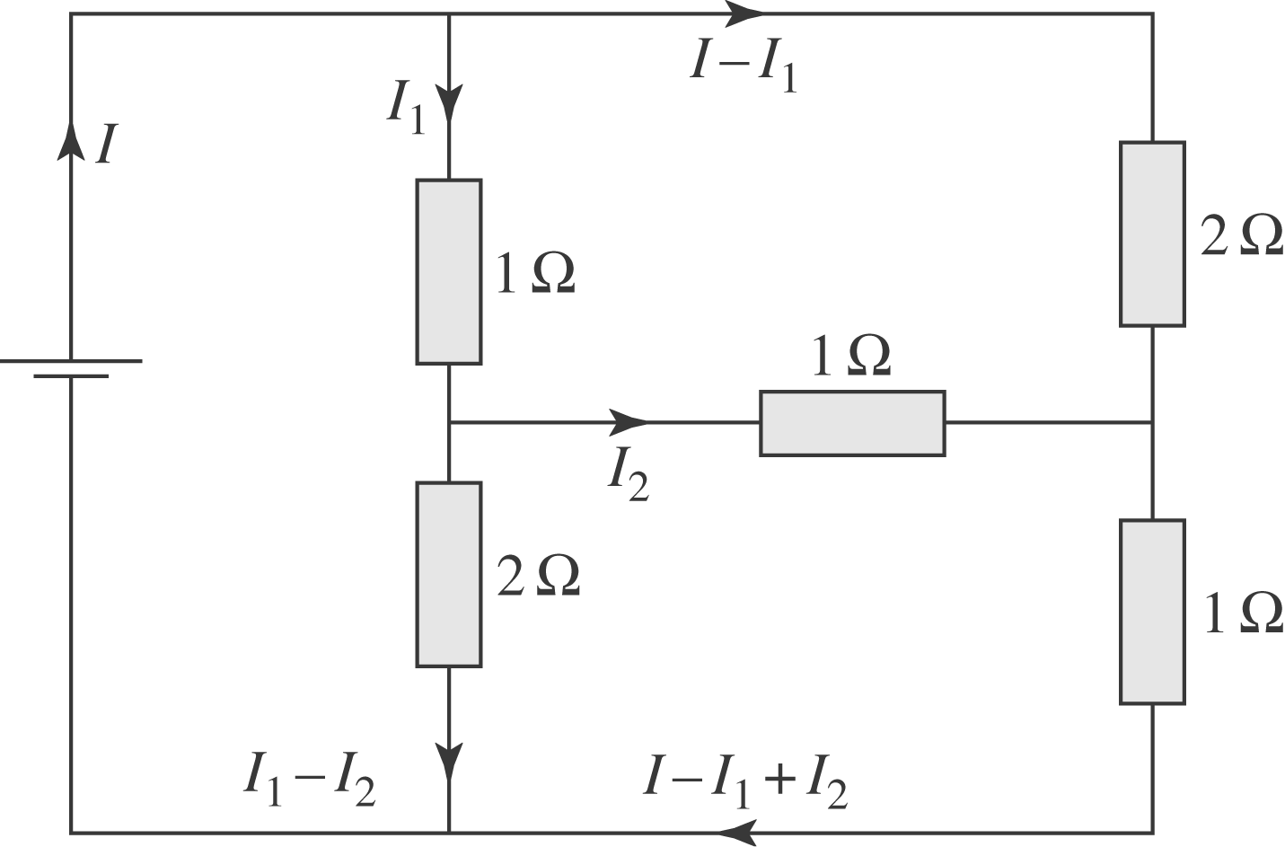
$$\begin{aligned}\text{Left} \text{loop:} \text{14} − I_{1} − 2(I_{1} − I_{2}) =0 \\ ⇒3I_{1} − 2I_{2} = \text{14}\text{.} \\ \text{Top} \text{loop}: −2(I − I_{1}) +I_{2} + I_{1} = 0 \\ ⇒−2I + 3I_{1} + I_{2} = 0\text{.} \\ \text{Bottom} \text{loop}: −(I − I_{1} + I_{2}) + 2(I_{1} − I_{2}) − I_{2} = 0 \\ ⇒−I + 3I_{1} − 4I_{2} = 0\text{.}\end{aligned}$$
Solving these equations for the currents we find:
$$I = I_{\text{battery}} = \text{10}\text{.}0 A; I_{1} = I_{R_{1}} = 6\text{.}0 \text{A;} I_{2} = I_{R_{3}} = 2\text{.}0 A\text{.}$$
So the other currents are:
$$I_{R_{2}} = I−I_{1}=4\text{.}0 \text{A;} I_{R_{4}} =I_{1}−I_{2}=4\text{.}0 \text{A;} I_{R_{5}}=I−I_{1}+I_{2} = 6\text{.}0 A\text{.}$$
$b) R_{\text{eq}} =\frac{V}{I} = \frac{\text{14}\text{.}0 V}{\text{10}\text{.}0 A} = 1\text{.}\text{40} Ω\text{.}$

