26.62: a) First do series/parallel reduction:
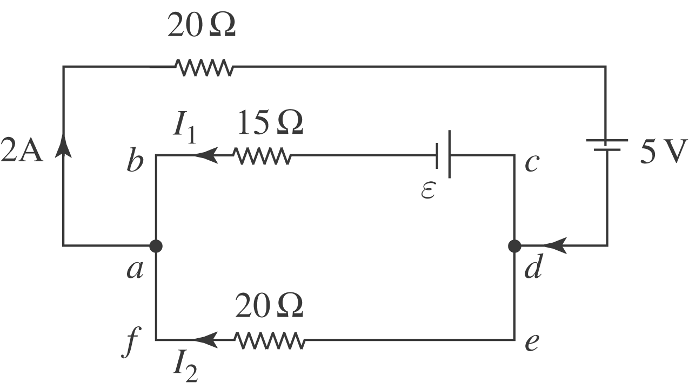
Now apply Kirchhoff’s laws and solve for $ε\text{.}$
$$\begin{aligned}{ΔV}_{\text{adefa}} = 0: −(\text{20} Ω)(2 A)−5 V−(\text{20} Ω)I_{2} = 0 \\ I_{2} = −2\text{.}\text{25} A \\ I_{1} + I_{2} = 2 A → I_{1} = 2 A − (−2\text{.}\text{25} A) = 4\text{.}\text{25} A\end{aligned}$$
$$\begin{aligned}{ΔV}_{\text{abcdefa}} = 0 : (\text{15} Ω ) (4\text{.}\text{25} A) + ε − (\text{20} Ω) ( −2\text{.}\text{25} A) = 0 \\ ε = −\text{109} \text{V;} \text{polarity} \text{should} \text{be reversed}\text{.}\end{aligned}$$
b) Parallel branch has a $\text{10} Ω \text{resistance}$.
$${ΔV}_{\text{par}} = \text{RI}=(\text{10} Ω) (2A) = \text{20} V$$
Current in upper part: $I =\frac{ΔV}{R} = \frac{\text{20} V}{\text{30} Ω} = \frac{2}{3} A$
$$\begin{aligned}\text{Pt} = U → I^{2} \text{Rt} = U \\ {\left(\frac{2}{3} A\right)}^{2} (\text{10} Ω)t = \text{60} J \\ t = \text{13}\text{.}5 s\end{aligned}$$

