26.63:
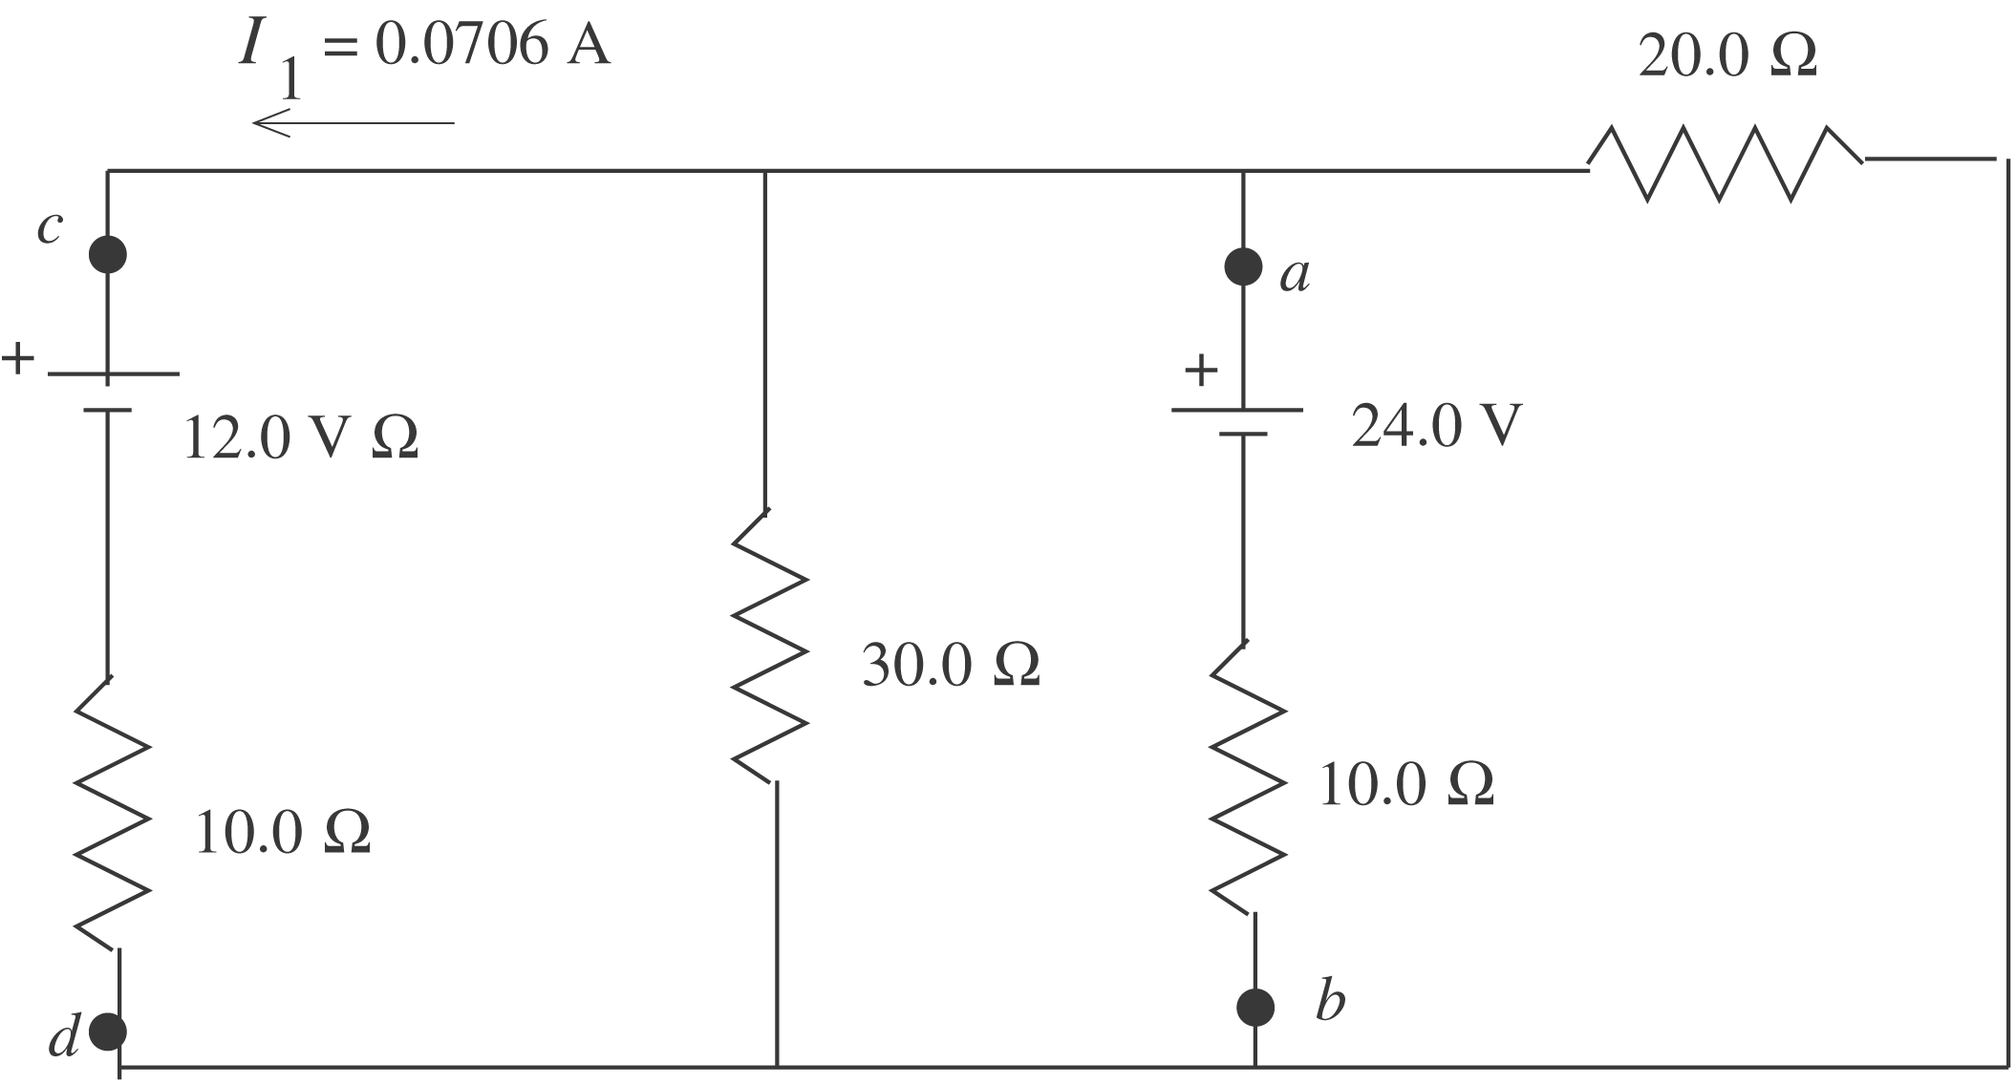
$$\begin{aligned}V_{d} + I_{1}(\text{10}\text{.}0 Ω) + \text{12}\text{.}0 V=V_{c} \\ V_{c} − V_{d}=\text{12}\text{.}\text{706} V; V_{a} − V_{b}=V_{c} − V_{d}=\text{12}\text{.}7 V\end{aligned}$$

