26.65: The 20.0-$Ω$ and 30.0-$Ω$ resistors are in parallel and have equivalent resistance 12.0 $Ω$. The two resistors R are in parallel and have equivalent resistance R/2. The circuit is equivalent to
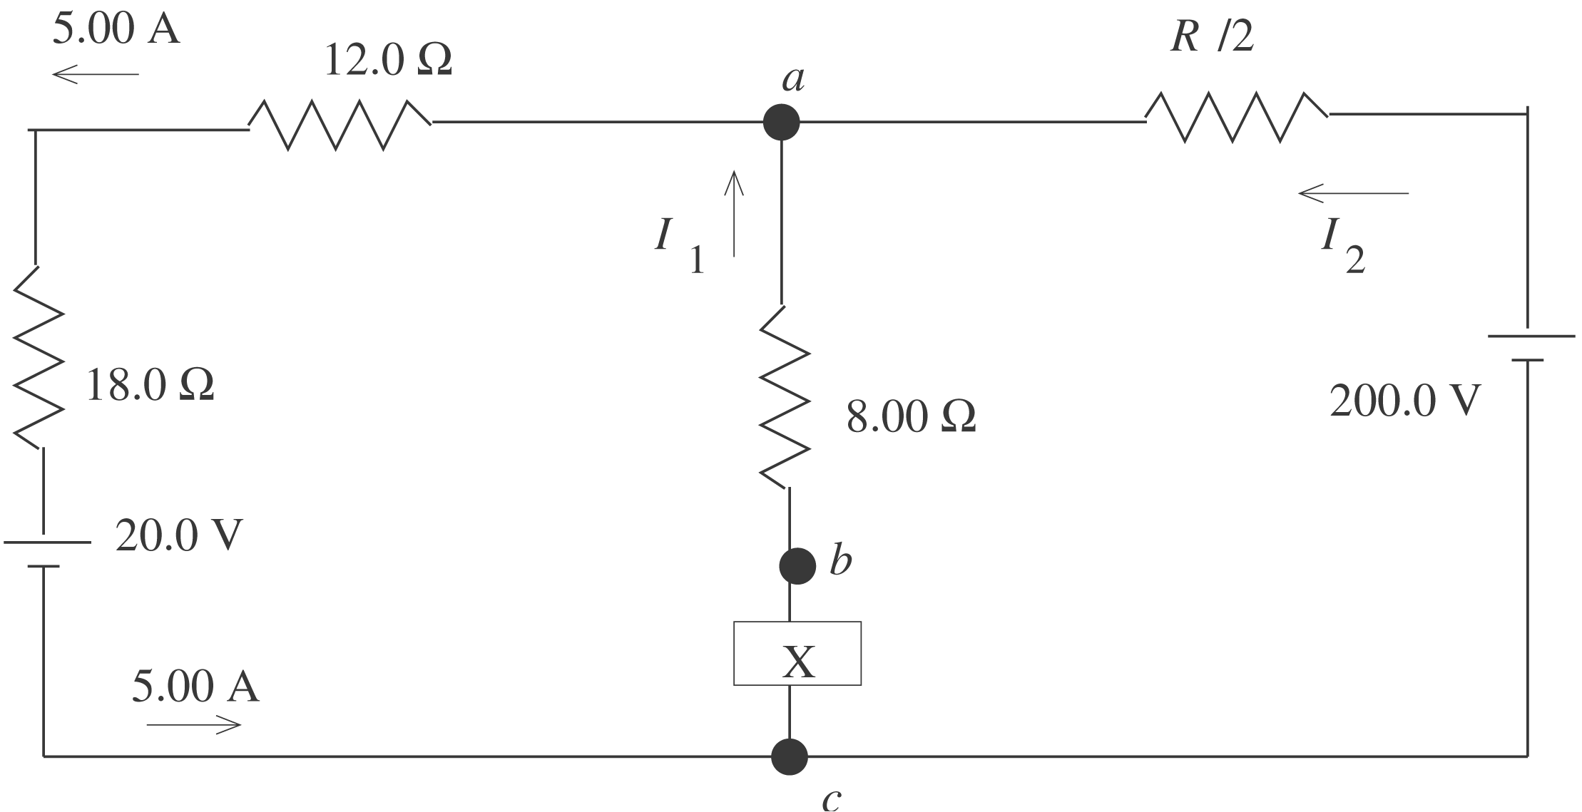

a) $V_{a} − (5\text{.}\text{00} A)(\text{12}\text{.}0 Ω) − (5\text{.}\text{00} A)(\text{18}\text{.}0 Ω) − \text{20}\text{.}0 V=V_{c}$
$$\begin{aligned}V_{c} − V_{a} =\text{20}\text{.}0 V + \text{90}\text{.}0 V + \text{60}\text{.}0 V=\text{170}\text{.}0 V \\ V_{b}− V_{a}=V_{\text{ba}}=\text{16}\text{.}0 V \\ X − V_{\text{ba}}=\text{170}\text{.}0 V \text{so} X=\text{186}\text{.}0 \text{V,}\text{with}\text{the}\text{upper}\text{terminal} + \end{aligned}$$

b) $I_{1}=(\text{16}\text{.}0 V)/(8\text{.}\text{00} Ω) =2\text{.}\text{00} A$
The junction rule applied to point a gives $I_{2}+I_{1} =5\text{.}\text{00} A, \text{so} I_{2} =3\text{.}\text{00} A\text{.}$ The
current through the 200.0 V battery is in the direction from the $− \text{to} \text{the} +$terminal, as shown in the diagram.
c) 200.0 V$− I_{2}(R/2) =\text{170}\text{.}0 V$
(3.00 A)$(R/2) =\text{30}\text{.}0 V \text{so R }=\text{20}\text{.}\text{0 }Ω$

