26.91: We can re-draw the circuit as shown below:
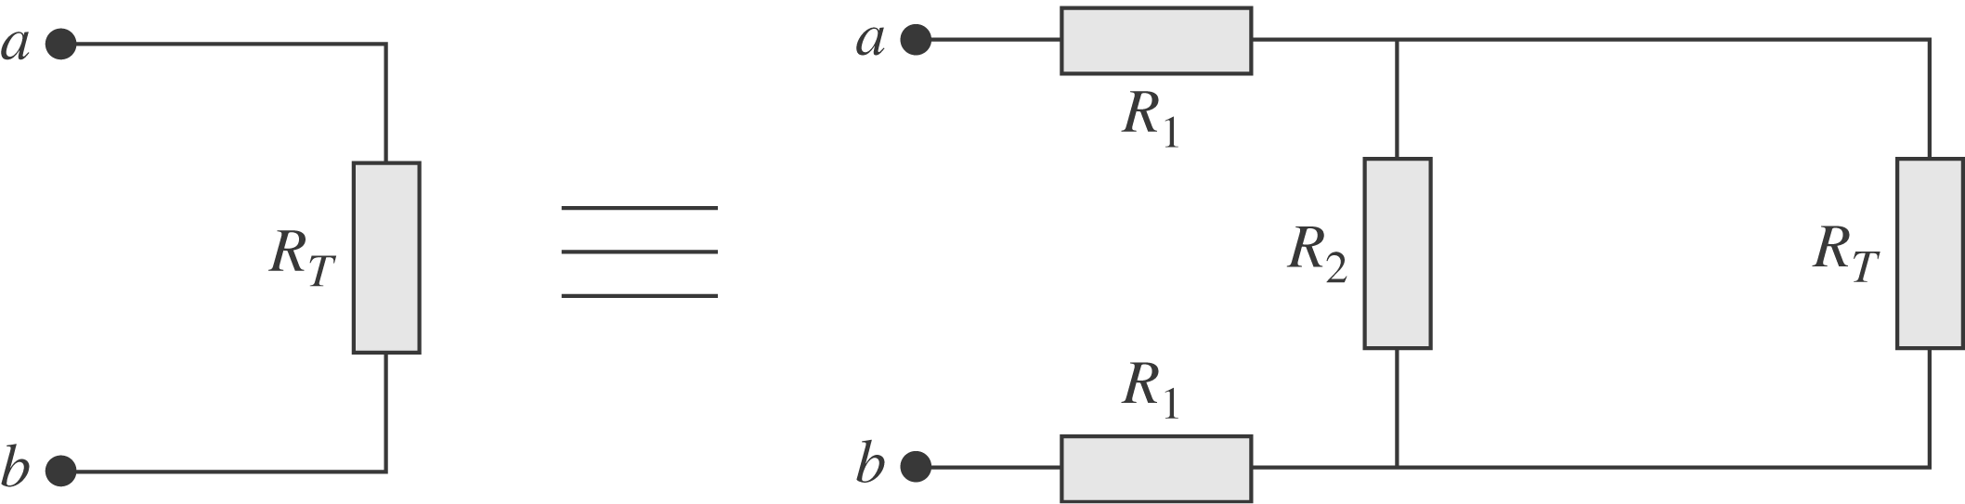
$\begin{aligned}⇒ R_{T}=2R_{1} + {\left(\frac{1}{R_{2}} + \frac{1}{R_{T}}\right)}^{−1}=2R_{1} + \frac{R_{2}R_{T}}{R_{2} + R_{T}}⇒R_{T^{2}} − 2R_{1}R_{T} − 2R_{1}R_{2}=0\text{.} \\ ⇒ R_{T}=R_{1} ± \sqrt{R_{1^{2}} + 2R_{1}R_{2}} \text{but} R_{T} > 0 ⇒ R_{T}=R_{1} + \sqrt{R_{1^{2}} + 2R_{1}R_{2}\text{.}}\end{aligned}$

