26.92:
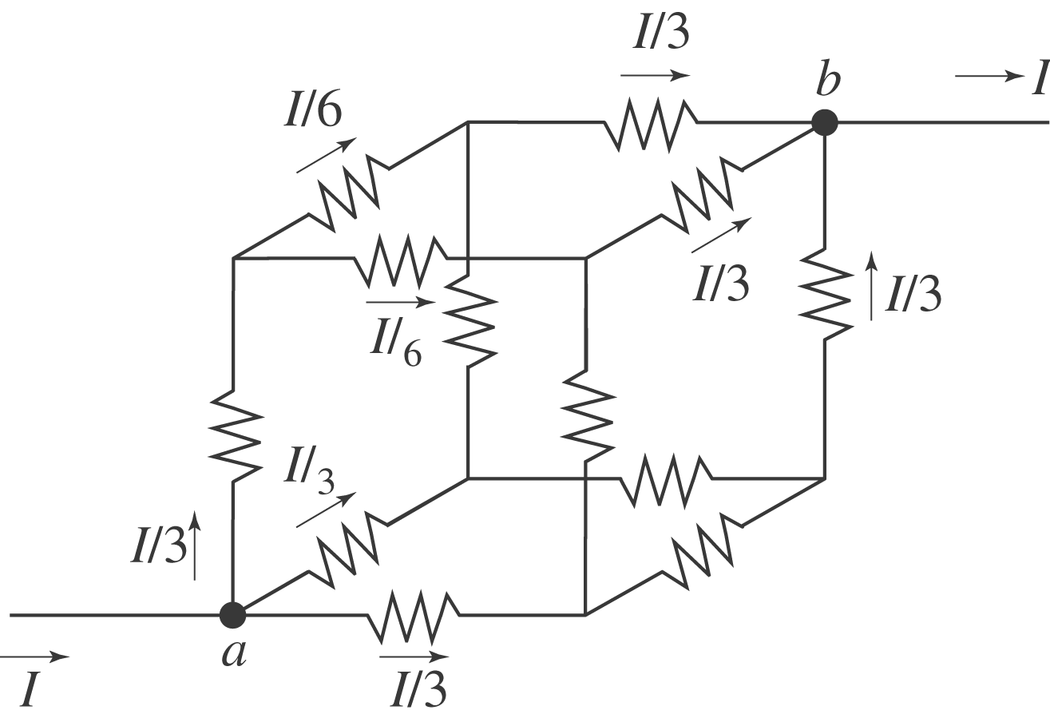
Let current $I \text{enter} \text{at} a \text{and} \text{exit} \text{at} b\text{.}$ At $a$ there are three equivalent branches, so current is $I/3$ in each. At the next junction point there are two equivalent branches so each gets current $I/6\text{.}$ Then at $b$ there are three equivalent branches with current $I/3$ in each. The voltage drop from $a \text{to} b$ then is $V=\left(\frac{I}{3}\right) R+ \left(\frac{I}{6}\right) R + \left(\frac{I}{3}\right) R=\frac{5}{6}\text{IR}\text{.}$ This must be the same as $V={\text{IR}}_{\text{eq}}, \text{so} R_{\text{eq}}=\frac{5}{6}R\text{.}$

