26.93: a) The circuit can be re-drawn as follows:
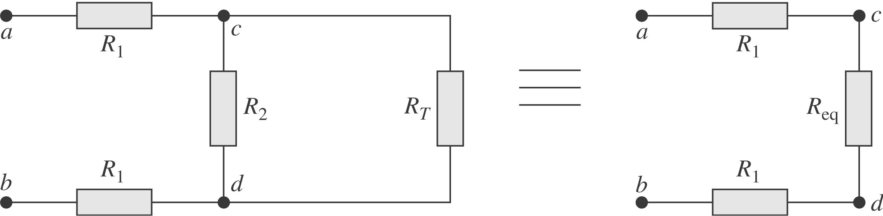
Then $V_{\text{cd}}=V_{\text{ab}}\frac{R_{\text{eq}}}{2R_{1} + R_{\text{eq}}}=V_{\text{ab}}\frac{1}{2{R_{1}}/{R_{\text{eq}}} + 1}$ and $R_{\text{eq}}=\frac{R_{2}R_{T}}{R_{2} + R_{T}}$.
But $β=\frac{2R_{1}(R_{T} + R_{2})}{R_{T}R_{2}}=\frac{2R_{1}}{R_{\text{eq}}}⇒ V_{\text{cd}}=V_{\text{ab}}\frac{1}{1 + β}$.
b) Recall $V_{1}=\frac{V_{0}}{(1 + β)} ⇒ V_{2}=\frac{V_{1}}{(1 + β)}=\frac{V_{0}}{(1+ β)^{2}} ⇒ V_{n}=\frac{V_{n − 1}}{(1 + β)}=\frac{V_{0}}{(1 + β)^{n}}$.
If $R_{1}=R_{2} ⇒ R_{T}=R_{1} + \sqrt{R_{1^{2}} + 2R_{1}R_{1}}=R_{1}(1 + \sqrt{3})$ and $β=\frac{2(2 + \sqrt{3})}{1 + \sqrt{3}}=2\text{.}\text{73}$. So, for the nth segment to have 1% of the original voltage, we need:
$\frac{1}{(1 + β)^{n}}=\frac{1}{(1 + 2\text{.}\text{73})^{n}} ≤ 0\text{.}\text{01} ⇒ n=4: V_{4}=0\text{.}\text{005}V_{0}$.

c) $R_{T}=R_{1} + \sqrt{R_{1^{2}} + 2R_{1}R_{2}}$
$\begin{aligned}⇒ R_{T}=\text{6400} Ω + \sqrt{(\text{6400} Ω)^{2} + 2(\text{6400} Ω) (8\text{.}0 × {\text{10}}^{8} Ω)}=3\text{.}2 × {\text{10}}^{6} Ω\text{.} \\ ⇒ β=\frac{2(\text{6400} Ω) (3\text{.}2 × {\text{10}}^{6} Ω +8\text{.}0× {\text{10}}^{8} Ω)}{(3\text{.}2 × {\text{10}}^{6} Ω) (8\text{.}0 × {\text{10}}^{8} Ω)}=4\text{.}0 × {\text{10}}^{−3}\text{.}\end{aligned}$

d) Along a length of 2.0 mm of axon, there are 2000 segments each 1.0 $μm$ long. The voltage therefore attenuates by:
$$V_{\text{2000}}=\frac{V_{0}}{(1 + β)^{\text{2000}}} ⇒ \frac{V_{\text{2000}}}{V_{0}}=\frac{1}{(1 + 4\text{.}0 × {\text{10}}^{−3})^{\text{2000}}}=3\text{.}4 × {\text{10}}^{−4}\text{.}$$

e) If $R_{2}=3\text{.}3 × {\text{10}}^{\text{12}} Ω ⇒ R_{T}=2\text{.}1 × {\text{10}}^{8} Ω$ and $β=6\text{.}2 × {\text{10}}^{−5}\text{.}$
$$⇒ \frac{V_{\text{2000}}}{V_{0}}=\frac{1}{(1 + 6\text{.}2 × {\text{10}}^{−5})^{\text{2000}}}=0\text{.}\text{88}\text{.}$$

