35.2: a) At $S_{1},r_{2}−r_{1}=4λ,$and this path difference stays the same all along the $y\text{-axis,}$so $m\text{=+}4\text{.} \text{At} S_{2},r_{2}−r_{1}=−4λ,$ and the path difference below this point, along the negative $y$-axis, stays the same, so $m=−4\text{.}$
b)

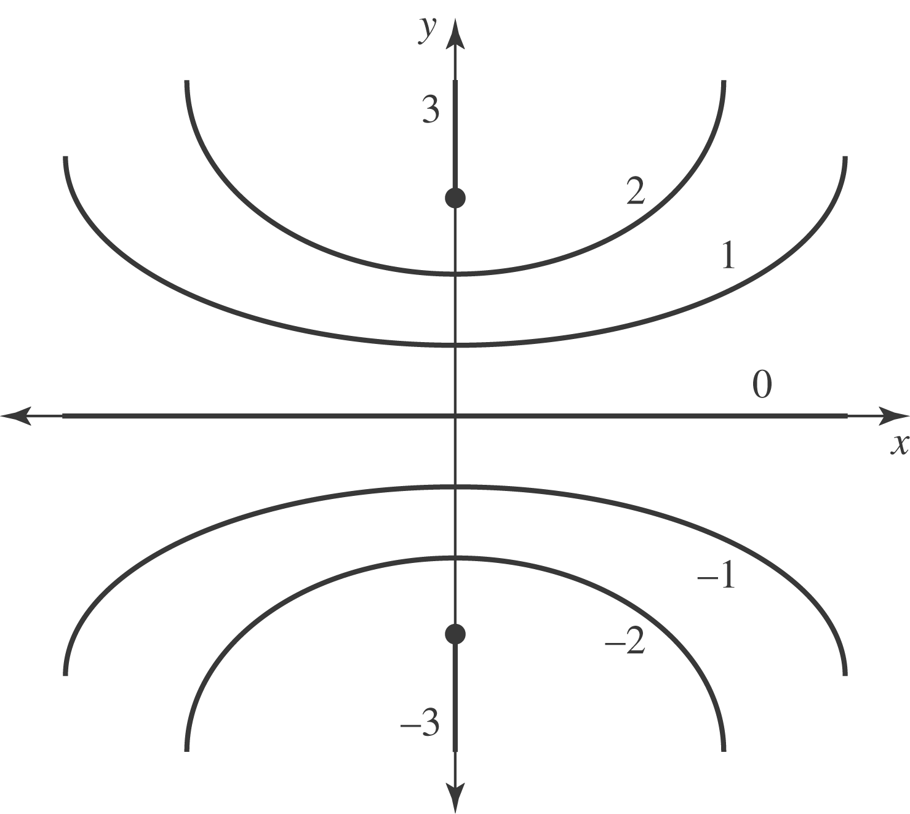

c) The maximum and minimum m-values are determined by the largest integer less than or equal to $\frac{d}{λ}\text{.}$
d) If $d=7\frac{1}{2}λ⇒−7≤m≤+7,$ so there will be a total of 15 antinodes between the sources. (Another antinode cannot be squeezed in until the separation becomes six times the wavelength.)

