35.20:
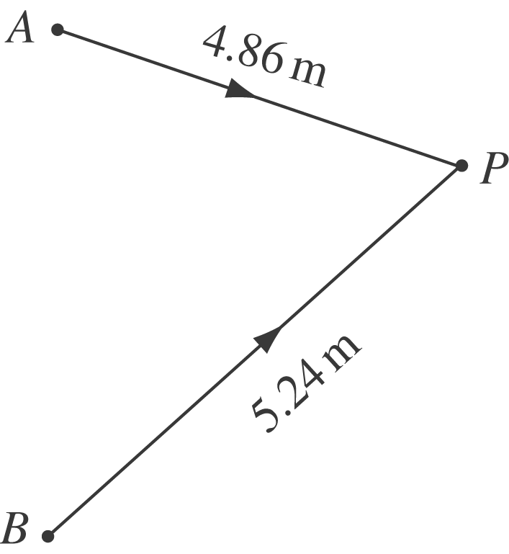 $\frac{Δφ}{2π}=\frac{\text{Path} \text{difference}}{λ}$
$Δφ=2π\left(\frac{\text{524}\text{cm}−\text{486} \text{cm}}{2 \text{cm}}\right)=\text{119} \text{radians}$

