35.40: Destructive interference occurs 1.7 m from the centerline.

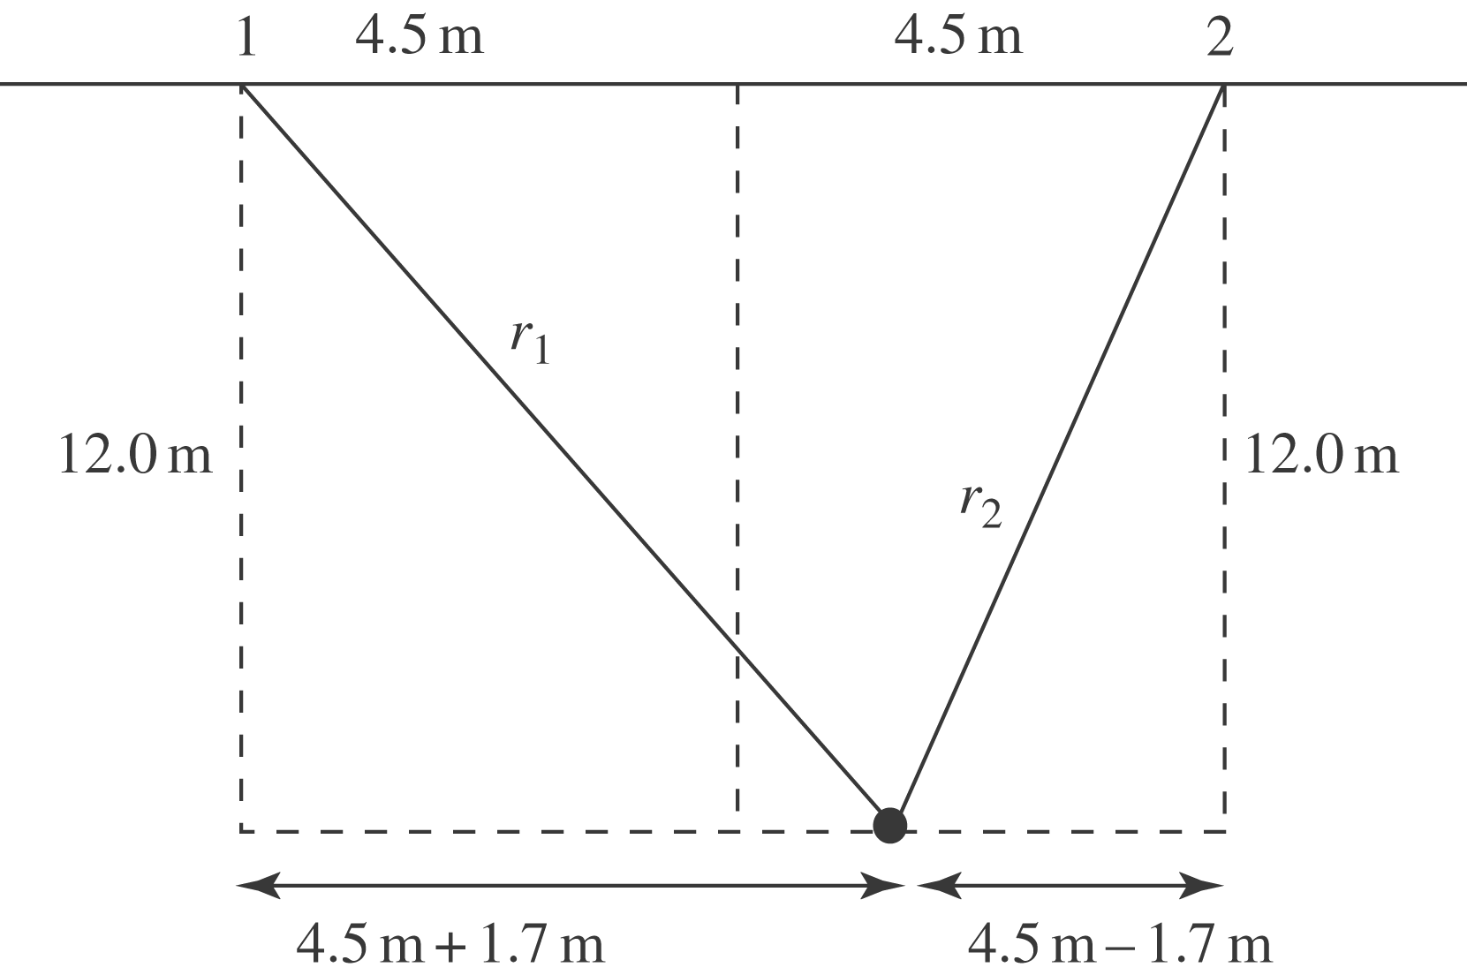

$r_{1}=\sqrt{(\text{12}\text{.}0 m)^{2}+(6\text{.}2 m)^{2}}$=13.51 m
$r_{2}=\sqrt{(\text{12}\text{.}0 m)^{2}+(2\text{.}8 m)^{2}}$=12.32 m
For destructive interference, $r_{1}−r_{2}=λ/2=1\text{.}\text{19} m$and $λ=2\text{.}4 m\text{.}$The wavelength we have calculated is the distance between the wave crests.
Note: The distance of the person from the gaps is not large compared to the separation of the gaps, so the path length is not accurately given by $d \text{sin} θ\text{.}$

