35.44: First find out what fraction the 0.159 ms time lag is of the period.
$Δt=\frac{0\text{.}\text{159}×{\text{10}}^{−3}s}{T}=(0\text{.}\text{159}×{\text{10}}^{−3}s)f=(0\text{.}\text{159}×{\text{10}}^{−3}s) (\text{1570} \text{Hz})$
$Δt=0\text{.}\text{250},$so the speakers are $1/4$ period out of phase. Let A be ahead of B in phase.

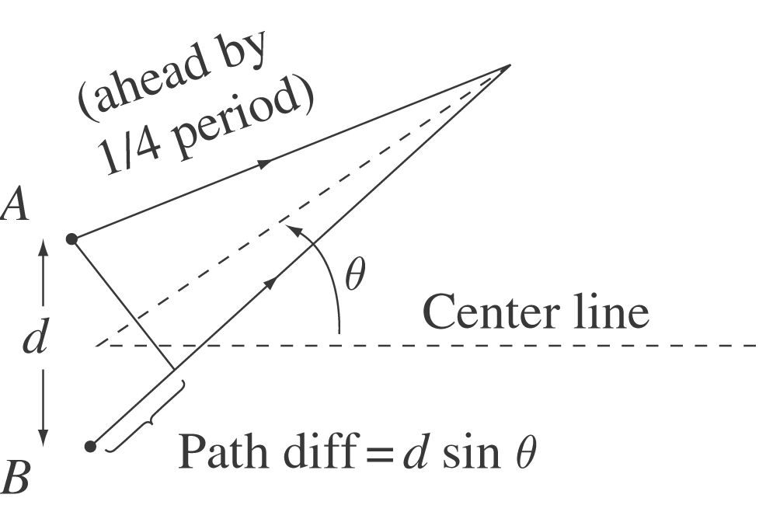

$$λ=v/f=\frac{\text{330} m/s}{\text{1570} \text{Hz}}=0\text{.}\text{210} m$$
$\text{On} A's \text{side} \text{of} \text{centerline}$: Since A is ahead by $1/4$ period, the path difference must retard B’s phase enough so the waves are in phase.
$\begin{aligned}d\text{sin}θ=\frac{3}{4}λ,\frac{7}{4}λ,\text{.}\text{.}\text{.} \\ \text{sin}θ_{1}=\frac{3}{4}\left(\frac{0\text{.}\text{210} m}{0\text{.}\text{422} m}\right)→θ_{1}=\text{21}\text{.}9° \\ \text{sin}θ_{2}=\frac{7}{4}\left(\frac{0\text{.}\text{210} m}{0\text{.}\text{422} m}\right)→θ_{2}=\text{60}\text{.}6°\end{aligned}$
$\text{On} B's \text{side} \text{of} \text{centerline}$: The path difference must now retard A’s sound by $\frac{1}{4}λ,\frac{5}{4}λ,…$
$−d\text{sin}θ=\frac{1}{4}λ,\frac{5}{4}λ,… \text{gives} − 7\text{.}2°, −\text{38}\text{.}5°$

