35.53: a) There is a half-cycle phase change at the glass, so for constructive interference:
$\begin{aligned}2d−x=2\sqrt{h^{2}+{\left(\frac{x}{2}\right)}^{2}}−x=\left(m+\frac{1}{2}\right)λ \\ ⇒\sqrt{x^{2}+4h^{2}}−x=\left(m+\frac{1}{2}\right)λ\text{.}\end{aligned}$
Similarly for destructive interference:
$\sqrt{x^{2}+4h^{2}}−x=mλ\text{.}$

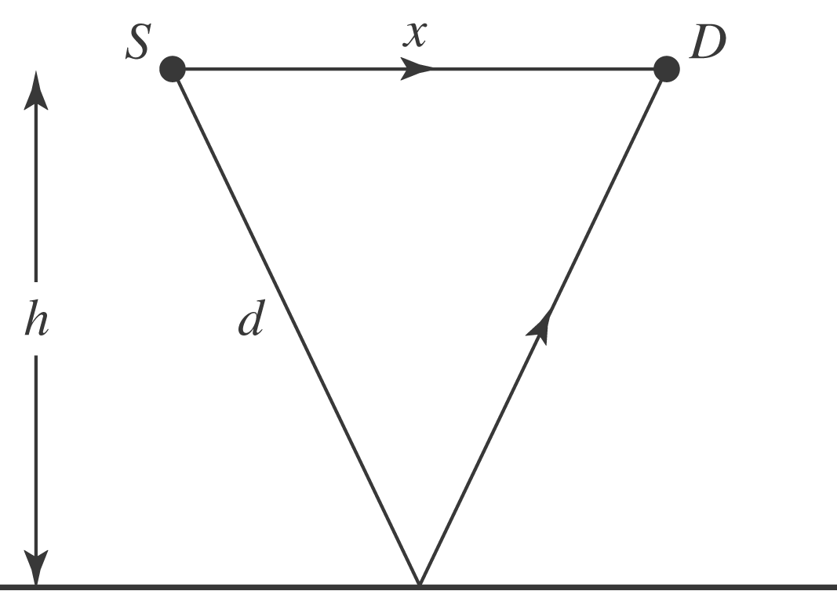

b) The longest wavelength for constructive interference is when $m=0:$
$λ=\frac{\sqrt{x^{2}+4h^{2}}−x}{m+\frac{1}{2}}=\frac{\sqrt{(\text{14} \text{cm})^{2}+4(\text{24} \text{cm})^{2}}−\text{14} \text{cm}}{1/2}=\text{72} \text{cm}\text{.}$

