36.16: The total intensity is given by drawing an arc of a circle that has length $E_{0}$ and finding the length of the cord which connects the starting and ending points of the curve. So graphically we can find the electric field at a point by examining the geometry as shown below for three cases.
a) $β=\frac{2πa}{λ} \text{sin} θ=\frac{2πa}{λ} ⋅ \frac{λ}{2a}=π\text{.}$ From the diagram, $π\frac{E_{p}}{2}=E_{0} ⇒ E_{p}=\frac{2}{π}E_{0}\text{.}$
So the intensity is just: $I={\left(\frac{2}{π}\right)}^{2} I_{0}=\frac{4I_{0}}{π^{2}}\text{.}$
This agrees with Eq. (36.5).

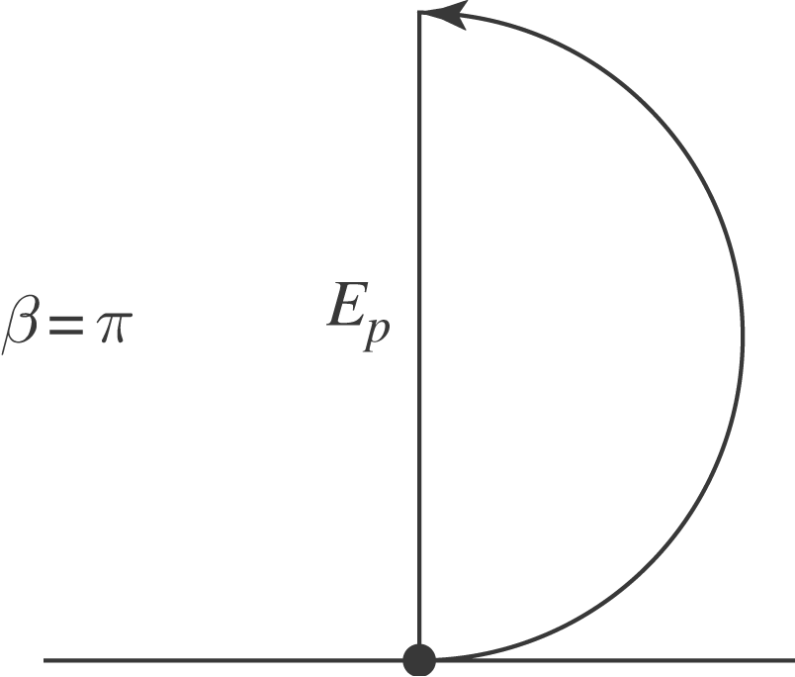
b)$β=\frac{2πa}{λ} \text{sin} θ=\frac{2πa}{λ} ⋅ \frac{λ}{a}=2π\text{.}$ From the diagram, it is clear that the total amplitude is zero, as is the intensity. This also agrees with Eq. (36.5).

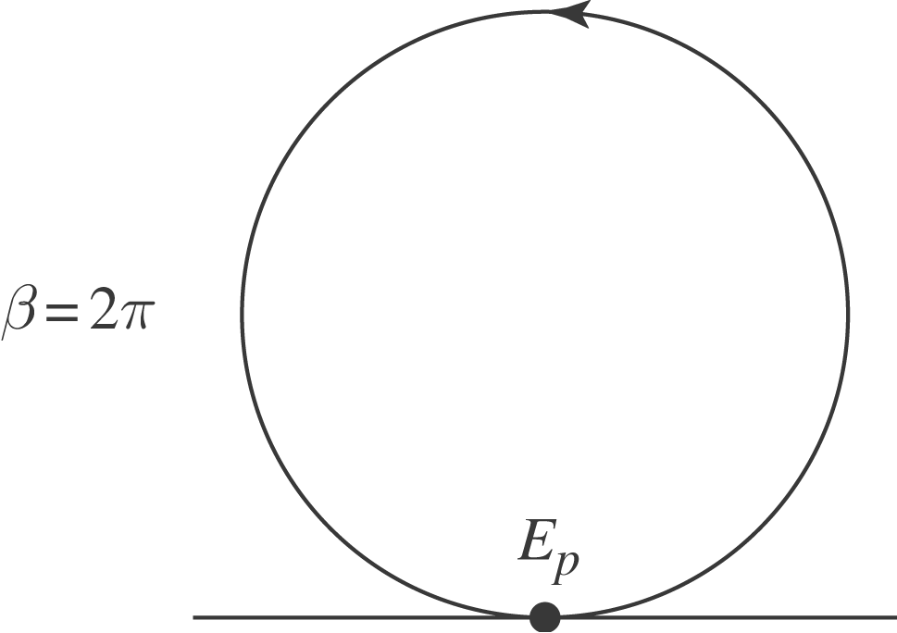
c) $β=\frac{2πa}{λ} \text{sin} θ=\frac{2πa}{λ} ⋅ \frac{3λ}{2a}=3π\text{.}$ From the diagram,$3π\frac{E_{p}}{2}=E_{0} ⇒ E_{p}=\frac{2}{3π}E_{0}\text{.}$ So the intensity is just:
$I={\left(\frac{2}{3π}\right)}^{2} I_{0}=\frac{4}{9π^{2}}I_{0}\text{.}$
This agrees with Eq. (36.5).

