36.23: With four slits there must be four vectors in each phasor diagram, with the orientation of each successive one determined by the relative phase shifts. So:

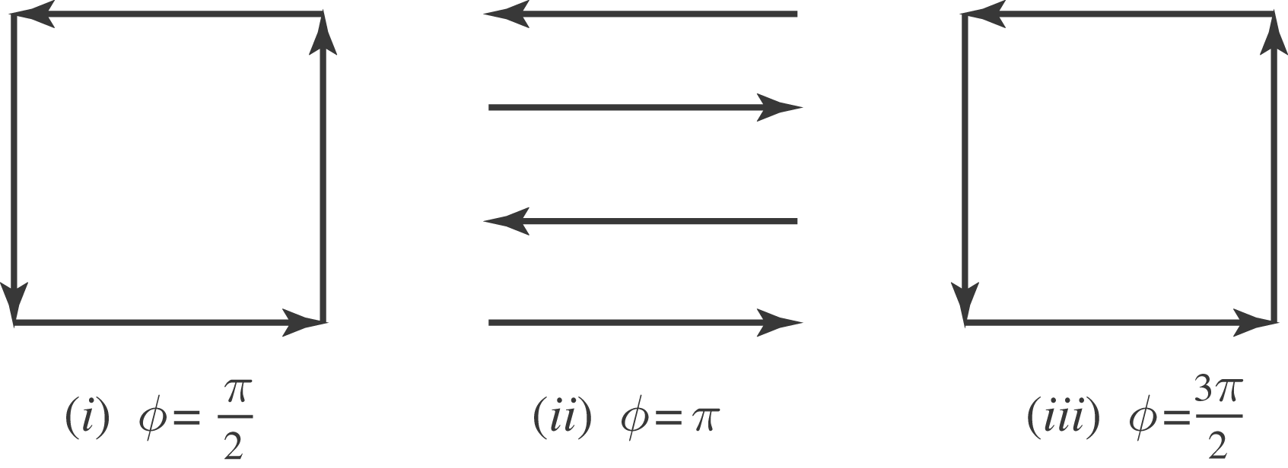

We see that destructive interference occurs from adjacent slits in case (ii) and from alternate slits in cases (i) and (iii).

