36.26: The third bright band is missing because the first order single slit minimum occurs at the same angle as the third order double slit maximum.

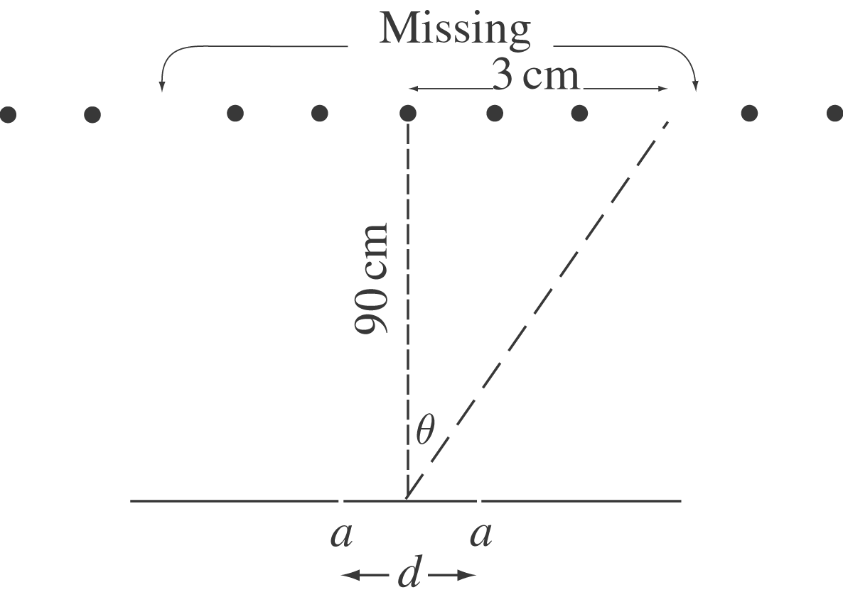 $\begin{aligned}\text{tan} θ=\frac{3 \text{cm}}{\text{90} \text{cm}} \\ θ=1\text{.}\text{91}°\end{aligned}$

Single-slit dark spot: $a \text{sin} θ=λ$
$$a=\frac{λ}{\text{sin} θ}=\frac{\text{500} \text{nm}}{\text{sin} 1\text{.}\text{91}°}=1\text{.}\text{50}×{\text{10}}^{4} \text{nm}(\text{width})$$
Double-slit bright fringe:
$$d \text{sin} θ=3λ$$
$d=\frac{3λ}{\text{sin} θ}=\frac{3(\text{500} \text{nm})}{\text{sin} 1\text{.}\text{91}°}=4\text{.}\text{50}×{\text{10}}^{4} \text{nm}(\text{separation})$

