36.48: Smallest resolving angle is for short-wavelength light(400 nm)
$θ≈1\text{.}\text{22}\frac{λ}{D}=(1\text{.}\text{22})\frac{\text{400}×{\text{10}}^{−9} m}{5\text{.}\text{08} m}=9\text{.}\text{61}×{\text{10}}^{−8} \text{rad}$

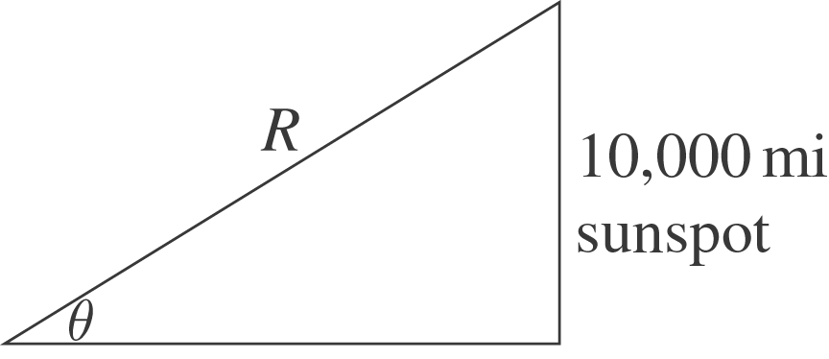 $θ=\frac{\text{10},\text{000} \text{mi}}{R}$

$R=\frac{\text{10},\text{000} \text{mi}}{θ}=\frac{\text{16},\text{000} \text{km}}{9\text{.}6× {\text{10}}^{−8}\text{rad}}=1\text{.}7×{\text{10}}^{\text{11}} \text{km}$
This is less than a light year, so there are no stars this close.

