36.58: a) $E_{p}^{2}=E_{p_{x}}^{2}+E_{p_{y}}^{2}\text{.}$So, from the diagram at right,
we have:
$\begin{aligned}\frac{E_{p}^{2}}{E_{0}^{2}}=(1+\text{cos}φ+\text{cos}2φ)^{2}+(\text{sin}φ+\text{sin}2φ)^{2} \\ (2 {\text{cos}}^{2}φ+\text{cos}φ)^{2}+(\text{sin}φ+2\text{sin}φ\text{cos}φ)^{2} \\ ({\text{cos}}^{2}φ+{\text{sin}}^{2}φ)(1+2\text{cos}φ)^{2} \\ ⇒\frac{E_{p}^{2}}{E_{0}^{2}}=(1+2\text{cos}φ)^{2}⇒E_{p}=E_{0}(1+2\text{cos}φ)\text{.}\end{aligned}$
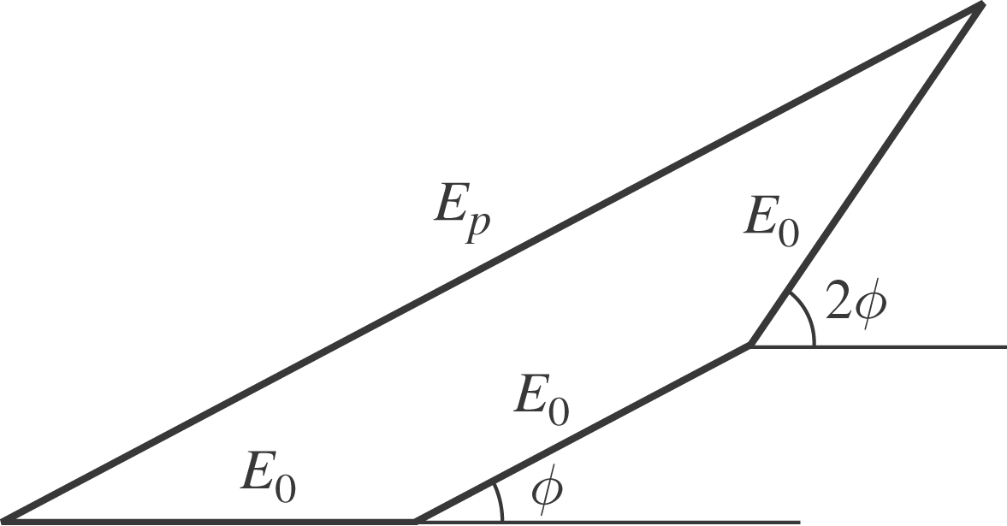

b) $φ=\frac{2πd}{λ}\text{sin}θ⇒I_{p}=I_{0}{\left(1+2\text{cos}\left(\frac{2πd\text{sin}θ}{λ}\right)\right)}^{2}\text{.}$ This is graphed below:
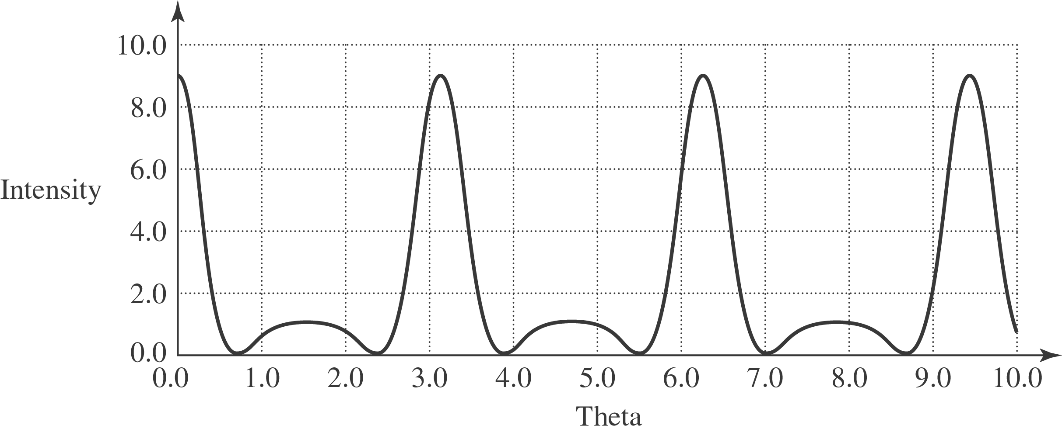

c) (i) At$θ=0,I_{p}=I_{0}(1+2\text{cos}(0^{0}))^{2}=9I_{0}\text{.}$
(ii) The principal maximum is when $I_{0}\frac{2πd\text{sin}θ}{λ}=2πm⇒d\text{sin}θ=mλ$
(iii) & (iv) The minima occur at 2 cos $\left(\frac{2πd\text{sin}θ}{λ}\right)=−1⇒\frac{2πd\text{sin}θ}{λ}=\frac{2πm}{3}$
$⇒d\text{sin}θ=\frac{mλ}{3},$with m not divisible by 3. Thus there are two minima between every principal maximum.

(v) The secondary maxima occur when cos$\left(\frac{2πd \text{sin}θ}{λ}\right)=−1 ⇒ I_{p}=I_{0}=\frac{I_{\text{max}}}{9}\text{.}$
$$\text{Also} \frac{2πd \text{sin}θ}{λ}=mπ ⇒ d \text{sin}θ=\frac{mλ}{2}\text{.}$$
All of these findings agree with the $N\text{-slit}$statements in Section 35.5.
d) Below are phasor diagrams for specific phase shifts.

